A MAJOR PROJECT ON
“INTEGRATION OF OPEN-SOURCE SECURITY TOOLS FOR A UNIFIED SOC FRAMEWORK”


Submitted by:
Rupesh Mahato | [230023]
Sujal Lamichhane | [230024]
Ujjwal Kandel | [230026]

Submitted to:
Department of BCS (NT & CS)
Forbes College
Bharatpur-2, Kshetrapur
January 30th, 2026

EXECUTIVE SUMMARY
In today’s rapidly evolving cybersecurity environment, organizations require an integrated and automated approach to detect, correlate, and respond to threats in real time. This project focuses on building a unified Security Operations Center (SOC) framework using pfSense, Wazuh SIEM, Shuffle SOAR, MISP, VirusTotal, AlienVault OTX, TheHive, and Cortex as an interconnected monitoring and incident response ecosystem. The architecture combines perimeter security, log correlation, automated workflows, and threat intelligence enrichment within a controlled lab setting. Simulated attack scenarios including reconnaissance, exploitation, brute-force attempts, reverse shells, and malware activity were executed to test the system’s detection and automation capabilities. Wazuh successfully correlated alerts from both network and endpoint sources, Shuffle automated enrichment and response actions, and TheHive with Cortex provided detailed case management and analysis. This project demonstrates the effectiveness of integrating open-source and enterprise security tools to create a cost-efficient, scalable SOC environment suitable for academic research and real-world implementation. Ultimately, it highlights the importance of centralized visibility, layered defense, and automation in strengthening modern cybersecurity operations.
Key Words: SOC, Wazuh, pfSense, Shuffle SOAR, TheHive, Cortex, MISP, VirusTotal, AlienVault OTX, Threat Intelligence, SIEM, Incident Response, Reverse Shells, Cyberattacks.

TABLE OF CONTENTS
EXECUTIVE SUMMARY i
LIST OF FIGURES iv
LIST OF TABLES x
CHAPTER 1: INTRODUCTION 1
1.1 Background 1
1.2 Problem Statement 1
1.3 Objectives 2
1.4 Products and Service Requirements 2
CHAPTER 2: LITERATURE REVIEW 6
CHAPTER 3: METHODOLOGY 7
3.1 Network Architecture 7
3.2 Working Flow 8
3.3 Flowchart 9
3.4 Environmental Setup 10
3.4.1 Installing VMware Workstation Pro 10
3.4.2 Creating Virtual Machines 11
3.5 Installation and Configuration of pfSense Firewall 13
3.5.1 Configuring Nat: Outbound rule 19
3.5.2 LAN Rule 20
3.5.3 WAN Rule 21
3.5.4 Suricata Installation and Configuration on pfSense 22
3.5 Installation and Configuration of Wazuh Server in Ubuntu 28
3.6 Installing Wazuh Agent in pfSense 30
3.6.1 Confirm pfSense Wazuh Agent Status on Wazuh Manager 34
3.7 Installing Wazuh Agent in Windows (Vulnerable System) 35
3.8 Installing shuffle SOAR 37
3.9 MISP Installation and Configuration 40
3.10 Cortex Setup and Configuration 44
3.11 The Hive Configuration 46
3.12 Creating Analyzers 49
3.13 SOAR-Based Automated Threat Intelligence System 52
3.14 Add Input Sources (Triggers) 53
3.15 Connect Inputs to Processing Node: 55
3.16 Threat intelligence lookups start 57
3.17 Action step (Change Me) 61
3.18 Create Alert 63
3.19 Alert and Notification 64
CHAPTER 4: EPILOUGE 65
4.1 Expected Outcomes 65
4.2 Time Schedule 65
4.3 Budget Analysis 66
CONCLUSION 67
REFERENCE 68

LIST OF FIGURES
Figure 1. 1: pfSense 2
Figure 1. 2: Suricata 2
Figure 1. 3: Wazuh Agent 3
Figure 1. 4: Kali Linux 3
Figure 1. 5: Ubuntu 3
Figure 1. 6: Cortex 4
Figure 1. 7: TheHive 4
Figure 1. 8: MISP 4
Figure 1. 9: Shuffle 5
Figure 1. 10: AlienVault 5
Figure 1. 11: VirusTotal 5

Figure 3. 1: Network Architecture 7
Figure 3. 2: Network Architecture 7
Figure 3. 3: Working Flow 8
Figure 3. 4: Flowchart 9
Figure 3. 5: VMware Workstation Download 10
Figure 3. 6: Selecting the Type of Configuration 11
Figure 3. 7: Choosing the Installer Disc Image File 12
Figure 3. 8: Naming the Virtual Machine 12
Figure 3. 9: Customizing the Hardware for the Guest OS 13
Figure 3. 10: Starting pfSense in VMware 14
Figure 3. 11: Installing pfSense 14
Figure 3. 12: Selecting The WAN Interface 15
Figure 3. 13: Proceeding With The Installation 15
Figure 3. 14: Rebooting after the installation of pfSense completes 16
Figure 3. 15: Welcome Screen After Successful Rebooting 16
Figure 3. 16: Confirming the interface configuration in the pfSense initial configuration 17
Figure 3. 17: Configuring LAN Interface 17
Figure 3. 18: pfSense Login Page 18
Figure 3. 19: Changing Default Admin Password 18
Figure 3. 20: Selecting the Outbound NAT Mode as Hybrid 19
Figure 3. 21: Configuring the Outbound NAT Policy 19
Figure 3. 22: Selecting the Protocol, Source and Destination 20
Figure 3. 23: Saving the Changes 20
Figure 3. 24: LAN Rule 21
Figure 3. 25: Configuring WAN Rule 21
Figure 3. 26: Accessing the Package Manager to Find Suricata 22
Figure 3. 27: Installing Suricata 22
Figure 3. 28: Navigating Suricata in the Services Tab 23
Figure 3. 29: Choosing the WAN Interface 23
Figure 3. 30: Logging Settings 24
Figure 3. 31: Selecting the Required EVE Output Settings 24
Figure 3. 32: Enabling Promiscuous Mode 25
Figure 3. 33: Selecting the Rule Sets 25
Figure 3. 34: Updating the Rule Set 26
Figure 3. 35: Activating the Suricata 26
Figure 3. 36: Enabling the Required Rules 27
Figure 3. 37: Services 27
Figure 3. 38: Selecting the Preferred Language 28
Figure 3. 39: Ubuntu OS Login Page 28
Figure 3. 40: Installing packages 29
Figure 3. 41: Wazuh Server Login Page 29
Figure 3. 42: Wazuh Dashboard 30
Figure 3. 43: SSH connection to pfSense 30
Figure 3. 44: Editing the pfSense.conf File 31
Figure 3. 45: Enabling the FreeBSD 31
Figure 3. 46: Updating the Package Repository 32
Figure 3. 47: Checking the Wazuh-Agent Version 32
Figure 3. 48: Editing and Setting Wazuh Manager IP 33
Figure 3. 49: Enabling and Starting Wazuh Agent 33
Figure 3. 50: Opening pfSense.conf File using Nano 33
Figure 3. 51: Opening FreeBSD.conf File using Nano 33
Figure 3. 52: Disabling FreeBSD Official Repositories 34
Figure 3. 53: Cleaning Package Catalog 34
Figure 3. 54: Confirming Wazuh Agent Status in Manager 35
Figure 3. 55: Downloading Wazuh Agent 35
Figure 3. 56: Executing the Command to Install the Package 36
Figure 3. 57: Starting the Wazuh Agent Service 36
Figure 3. 58: Agent Successfully Connected to the Manager 36
Figure 3. 59 Docker and Docker Compose Active 37
Figure 3. 60 Docker Compose Installing 38
Figure 3. 61 Docker Compose Running 38
Figure 3. 62 Shuffle SOAR Login Page 39
Figure 3. 63: Shuffle Dashboard 39
Figure 3. 64: Changing Default Password 40
Figure 3. 65: Adding New Organization 40
Figure 3. 66: New Organization 41
Figure 3. 67: Adding New User 41
Figure 3. 68: Assigning User to The New Organization 42
Figure 3. 69: Users Index 42
Figure 3. 70: Creating Auth Key 43
Figure 3. 71: Created Auth Key 43
Figure 3. 72: Updating Cortex Database 44
Figure 3. 73: Creating New Cortex Organization 44
Figure 3. 74: Adding New User 45
Figure 3. 75: Setting Password 45
Figure 3. 76: TheHive Login Page 46
Figure 3. 77: Integrating Cortex with TheHive 46
Figure 3. 78: Successful Integration of Cortex and MISP 47
Figure 3. 79: Integrating MISP with TheHive 47
Figure 3. 80: Created Organization 48
Figure 3. 81: Creating New User 48
Figure 3. 82: Setting Password for The New User 49
Figure 3. 83: AbuseIPDB API Key 49
Figure 3. 84: VirusTotal API 50
Figure 3. 85: Analyzers Navigation 50
Figure 3. 86: VirusTotal 50
Figure 3. 87: VirusTotal Successfully Enabled 51
Figure 3. 88: AbuseIPDB 51
Figure 3. 89: Enabling AbuseIPDB Analyzer 51
Figure 3. 90: Overall SOAR Workflow Architecture 52
Figure 3. 91 Input triggers 53
Figure 3. 92 SOC Threat Alert from Discord 53
Figure 3. 93: Firewall Action / IP Blocking 54
Figure 3. 94: New TheHive Case Alert 54
Figure 3. 95: Central processing node for all incoming alerts 55
Figure 3. 96: pfSense IP Blocking Script 56
Figure 3. 97: TheHive Case Creation Script 56
Figure 3. 98: VirusTotal Integration 57
Figure 3. 99: AlienVault OTX Integration 58
Figure 3. 100: AbuseIPDB Integration 59
Figure 3. 101: Webhook URI 60
Figure 3. 102 Repeat back to me 61
Figure 3. 103 Result Correlation and Decision Engine 62
Figure 3. 104: Decision point for generating alerts 63
Figure 3. 105: Consolidated results and status messages 64

LIST OF TABLES
Table 4. 1: Time Schedule 66
Table 4. 2: Budget Analysis 66

ABBREVATIONS | DEFINITIONS
DMZ | Demilitarized Zone
HIDS | Host-based Intrusion Detection System
IDS | Intrusion Detection System
IPS | Intrusion Prevention System
NSM | Network Security Monitoring
SIEM | Security Information and Event Management
SMEs | Small and Medium-sized Enterprises
SOAR | Security, Orchestration, Automation and Response
SOC | Security Operations Center
VM | Virtual Machine
XDR | Extended Detection and Response
LIST OF ACRONYMS

CHAPTER 1: INTRODUCTION

1.1 Background
As digital infrastructures expand, organizations face increasing cyber threats such as malware infections, intrusion attempts, phishing campaigns, and data breaches, with these attacks growing more sophisticated and difficult to detect through traditional security mechanisms. To ensure continuous protection, the Security Operations Center (SOC) has become essential for real-time monitoring, detection, analysis, and response. However, building a SOC typically requires costly enterprise-grade tools that many small and medium-sized organizations cannot afford. To address this challenge, this project proposes a Unified SOC Framework that integrates pfSense as the perimeter firewall, Wazuh as the SIEM and endpoint monitoring platform, Shuffle for automated response, and threat intelligence sources such as MISP, VirusTotal, and AlienVault OTX, along with TheHive and Cortex for incident management and enrichment. These tools operate within a structured architecture encompassing an Isolation Zone, Corporate Perimeter, DMZ, and Internal LAN, enabling real-time threat detection, automated workflows, enriched intelligence, and efficient incident response that closely resembles the capabilities of a professional SOC environment.

1.2 Problem Statement
Even with the availability of multiple cybersecurity tools, organizations encounter major operational challenges:
- Alert fatigue: High volume of critical alerts leads to alert fatigue, making it challenging for SOC analysts to prioritize and respond effectively.
- Delayed Incident Response: Manual investigation, lack of automation, and scattered alerts slow down detection and response to threats.
- High Cost of SOC Implementation: Enterprise-grade SOC tools and infrastructure are expensive, making advanced security monitoring difficult for small and medium-sized organizations.

Objectives
The primary objectives of this project are as follows:
- Lowering MTTD (Mean Time to Detect) and MTTR (Mean Time to Respond)
- Integration of Security Tools: Unifies dashboards, logs, threat intelligence, and automation for faster detection and response.
- Automate Incident Response: Use SOAR workflows (Shuffle) and TheHive-Cortex to reduce manual work, speed up response and impove accuracy.

Products and Service Requirements

- pfSense Firewall Appliance: A free, open-source firewall and router distribution based on FreeBSD. pfSense provides enterprise-grade features such as NAT, VLANs, DHCP, DNS, and VPN support. In this project, pfSense is deployed as a virtual or physical appliance and serves as the perimeter security device, integrating with Suricata for network-level intrusion detection and traffic inspection [1].
Figure 1. 1: pfSense

- Suricata IDS/IPS Software: An open-source, high-performance network threat detection engine capable of real-time intrusion detection (IDS), intrusion prevention (IPS), and network security monitoring (NSM). Installed as a package in pfSense, Suricata operates in IDS mode to analyze packets, generate alerts on suspicious traffic patterns, and forward logs for correlation in Wazuh [2].
Figure 1. 2: Suricata
- Wazuh Manager and Dashboard: A comprehensive open-source Security Information and Event Management (SIEM) platform. It provides threat detection, integrity monitoring, log analysis, and incident response capabilities. Wazuh collects and correlates logs from both the network (Suricata) and host-level agents, displaying security events in its built-in web dashboard. It includes rule sets, decoders, and active responses to automate threat mitigation.

- Wazuh Agent Software: Lightweight agents installed endpoint machines (Windows/Linux) to monitor system activity, perform file integrity checks, collect audit logs, and report to the Wazuh Manager. These agents help provide host-based intrusion detection (HIDS) and full endpoint visibility for real-time alerting and correlation [3].
Figure 1. 3: Wazuh Agent

- Kali Linux Virtual Machine: An open-source, Debian-based Linux distribution specifically designed for penetration testing and ethical hacking. Kali Linux is used in the lab environment to simulate various attack vectors (e.g., brute-force, reverse shell, scanning, exploitation) to validate the detection and logging capabilities of the integrated system [4].
Figure 1. 4: Kali Linux

- Ubuntu/Windows Endpoints: Generic operating system platforms used as victim machines for attack simulation. They are equipped with Wazuh agents and are targeted by Kali Linux to generate real-world security events. These machines help demonstrate the effectiveness of Wazuh’s detection capabilities [5].
Figure 1. 5: Ubuntu


- Cortex: Cortex is an open-source, scalable analysis engine used to automate observable and artifact analysis. In the lab environment, Cortex connects with TheHive to process indicators such as IP addresses, hashes, URLs, and domains. It performs enrichment and malware analysis tasks using multiple analyzers (e.g., HybridAnalysis, VirusTotal, WHOIS). This enables the SOC to validate automated incident triaging, enrichment workflows, and threat-intelligence correlation capabilities [6].
Figure 1. 6: Cortex
- TheHive: TheHive is an open-source Security Incident Response Platform (SIRP) used for case management, alert handling, event correlation, and collaborative investigation. In the lab setup, TheHive integrates with Wazuh, Cortex, and MISP to collect alerts, create investigation cases automatically, assign tasks, and track response actions. It helps validate coordinated incident handling, analyst workflow automation, and traceability of security events [7].


Figure 1. 7: TheHive

- MISP: MISP (Malware Information Sharing Platform) is an open-source threat-intelligence sharing system designed to collect, store, and distribute Indicators of Compromise (IOCs). In the SOC lab, MISP is used to feed threat intelligence to TheHive and Cortex, allowing automated enrichment and correlation of suspicious activities detected by Wazuh. Its use enables testing of IOC ingestion, sharing workflows, and threat intelligence automation [8].
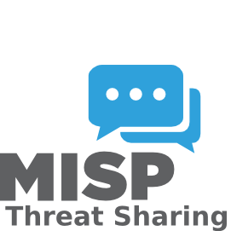
Figure 1. 8: MISP


- Shuffle SOAR: Shuffle is an open-source Security Orchestration, Automation, and Response (SOAR) platform used to automate incident workflows through drag-and-drop playbooks. In the lab environment, Shuffle integrates with Wazuh, TheHive, Cortex, and MISP to automate tasks such as alert forwarding, IOC enrichment, case creation, and email notifications. It is used to evaluate the SOC’s automation capabilities and reduce manual response time [9].

Figure 1. 9: Shuffle


- AlienVault: AlienVault is an open-source security information and event management platform combining asset discovery, vulnerability assessment, intrusion detection, and log correlation. In the lab setup, AlienVault is used to correlate logs from endpoints, firewalls, and detection tools to validate threat detection accuracy across multiple data sources. It plays a key role in testing SIEM event processing, correlation rules, and unified threat visibility [10].

Figure 1. 10: AlienVault


- VirusTotal: VirusTotal is a widely used cloud-based malware analysis and reputation service that aggregates results from multiple antivirus engines, sandboxes, and URL scanners. In the SOC lab, VirusTotal is used through Cortex analyzers to validate malicious file/hash detection, enrich investigation cases, and compare local detection results with global threat intelligence. This helps test reputation-based detection, IOC verification, and external threat-feed integration [11].
Figure 1. 11: VirusTotal

CHAPTER 2: LITERATURE REVIEW
Open-source Security Information and Event Management (SIEM) tools like Wazuh and OSSIM provide effective log monitoring, event correlation, and agent-based visibility, offering cost-efficient solutions for SOCs [12]. Studies such as SAIBERSOC show that these platforms can be tested for detection accuracy and response performance using simulated attacks [13].
Security Orchestration, Automation, and Response (SOAR) platforms reduce manual tasks and speed up incident investigation. Open-source solutions like Shuffle SOAR provide scalable automation, while threat intelligence platforms such as MISP and AlienVault OTX help analysts correlate alerts with global threat data [14].
Incident response tools like TheHive and Cortex enable collaborative investigations with case management and automated workflows. Modular SOC architectures demonstrate flexibility and adaptability, and integrating SIEM, SOAR, threat intelligence, and response tools improves detection accuracy and response time [15]. This project implements a unified open-source SOC framework leveraging these tools.

CHAPTER 3: METHODOLOGY

3.1 Network Architecture
Figure 3. 1: Network Architecture
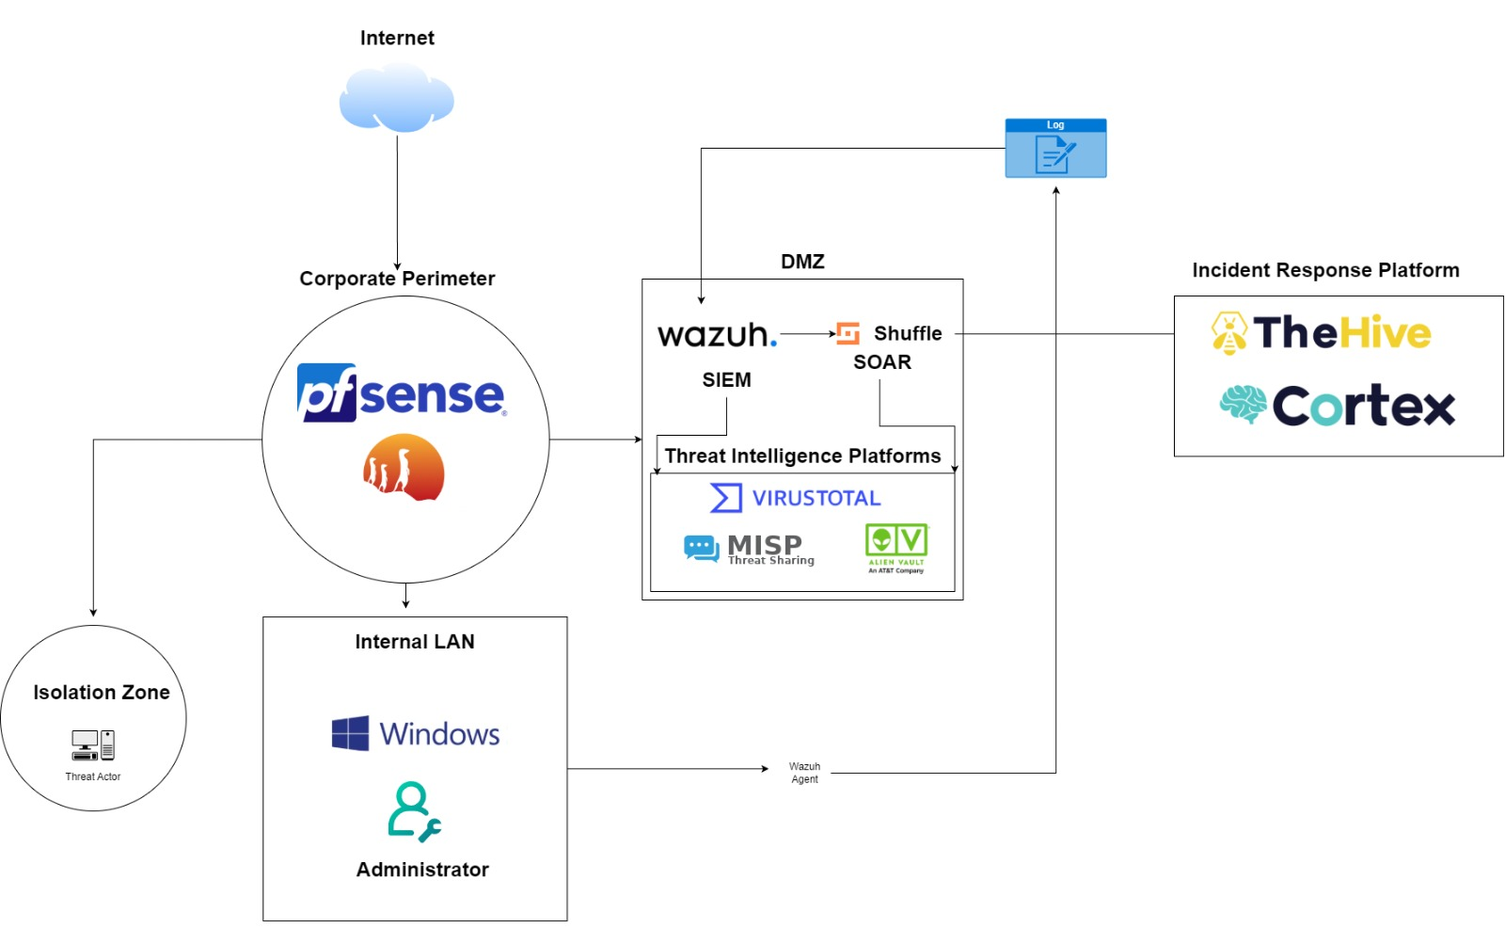
Figure 3. 2: Network Architecture

This SOC architecture uses pfSense as the main perimeter firewall to filter all Internet traffic, forwarding essential logs to the DMZ where Wazuh SIEM centrally collects and analyzes security data from pfSense, Windows endpoints, and threat-intelligence sources like VirusTotal, MISP, and AlienVault OTX. When Wazuh detects suspicious activity, it triggers Shuffle SOAR, which automates responses such as threat enrichment, blocking malicious IPs, and generating incidents in TheHive the primary incident-response platform. Cortex supports TheHive by performing deeper analysis of malware samples, file hashes, URLs, and IPs to accelerate investigations. Within the internal LAN, Windows systems send logs through Wazuh agents, and compromised machines can be moved to the isolation zone to prevent lateral movement. Together, this architecture delivers a unified, automated, intelligence-driven SOC for effective monitoring, detection, and incident response.

3.2 Working Flow
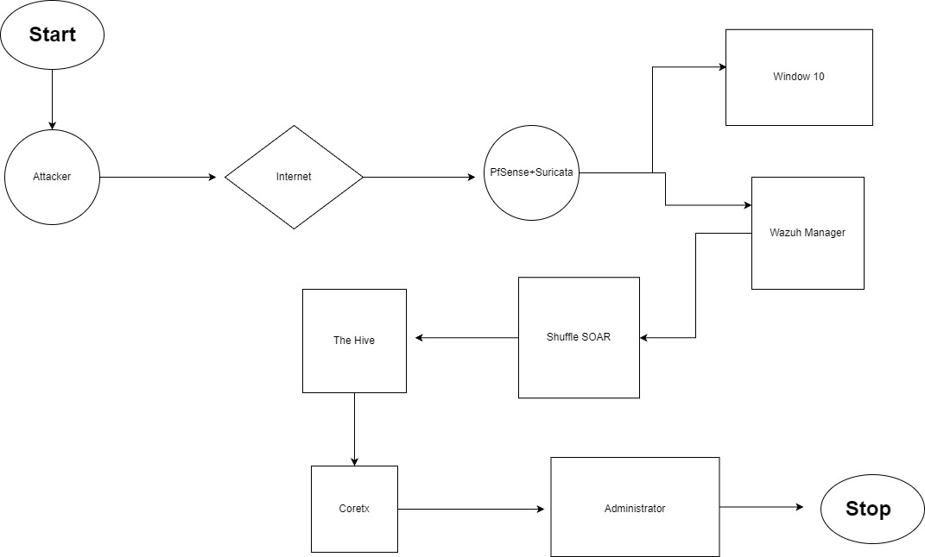
Figure 3. 3: Working Flow
This diagram illustrates the workflow of a unified SOC environment, beginning when an attacker sends malicious traffic through the internet toward the organization’s network, where pfSense and Suricata act as the first security layer by inspecting and detecting suspicious activity. The logs and alerts generated by these systems are forwarded to the Wazuh Manager, which correlates network and endpoint events from Windows 10 to identify potential threats. When a threat is detected, Wazuh sends the alert to Shuffle SOAR, which enriches and processes the information before automatically creating an incident case in TheHive for deeper investigation. From TheHive, analysts can run Cortex analyzers to gather additional threat intelligence, such as IP reputation or file hash analysis. Based on these insights, the administrator reviews the findings, applies necessary security actions such as blocking the attacker or updating firewall rules and concludes the incident, completing the workflow.
.

3.3 Flowchart
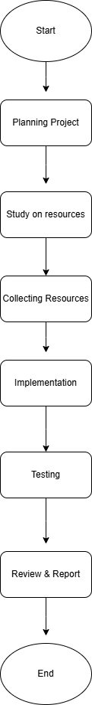
Figure 3. 4: Flowchart

3.4 Environmental Setup
This section explains how the virtual environment is configured to support the implementation of an integrated intrusion detection and security monitoring system using pfSense, Suricata, and Wazuh. The entire scenario is deployed using VMware Workstation Pro, where multiple virtual machines are created and connected through custom virtual networks to simulate realistic enterprise traffic and attack conditions.

3.4.1 Installing VMware Workstation Pro
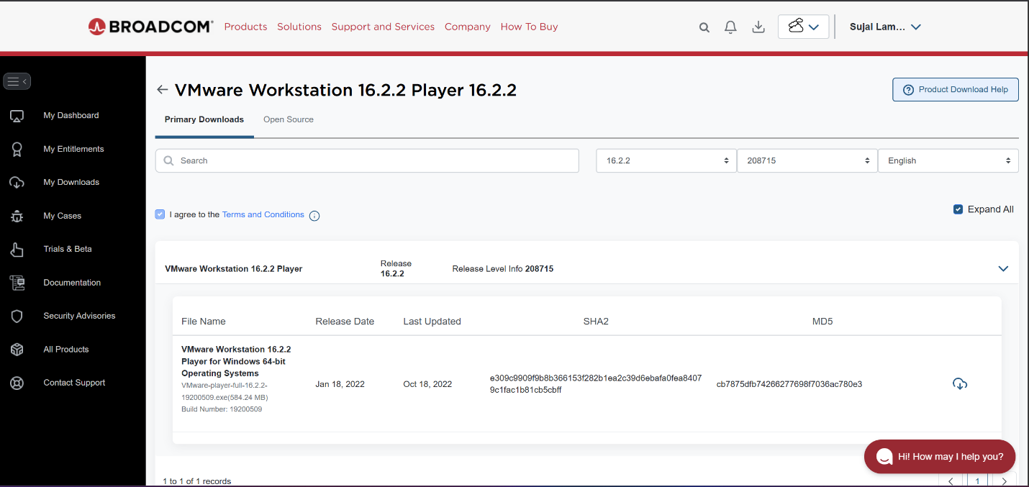
The first step in setting up the lab environment is to install VMware Workstation Pro on a physical machine.
Figure 3. 5: VMware Workstation Download
VMware Workstation Pro was installed by downloading the installer from the official VMware website and running the setup using default settings. The license agreement was accepted, the default installation path was used, and the enhanced keyboard driver was enabled when prompted. After installation, VMware Workstation Pro was launched and activated as required.

3.4.2 Creating Virtual Machines
After VMware is installed, the next step is to create virtual machines for each component of the architecture:
The process for creating a virtual machine in VMWare is same for all the VMs. So, follow same process to create virtual machines too.
Go to File > New Virtual Machine.

Then, Select “Typical (recommended)” and proceed.
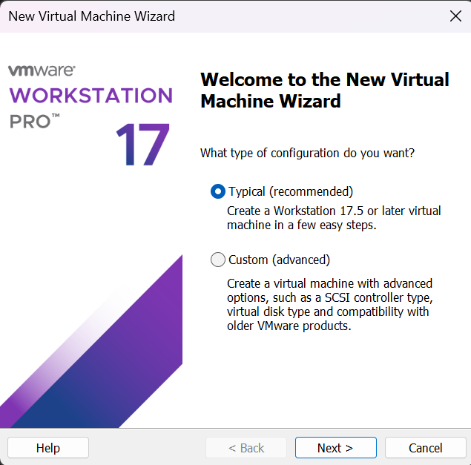
Figure 3. 6: Selecting the Type of Configuration

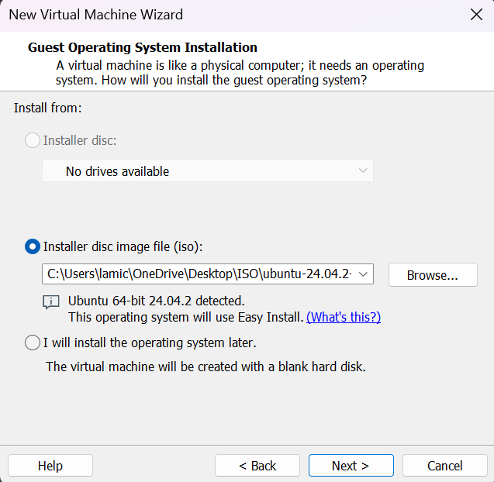
Choose “Installer disc image file (ISO)” and browse to the ISO of the OS you want to install.
Figure 3. 7: Choosing the Installer Disc Image File

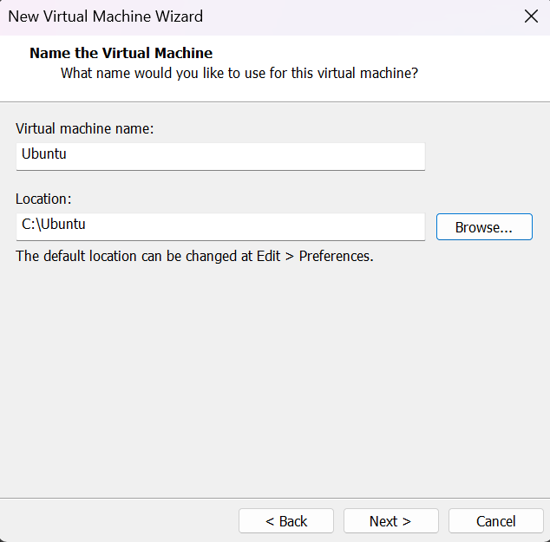
Then, provide the name to the Virtual Machine and Location.
Figure 3. 8: Naming the Virtual Machine
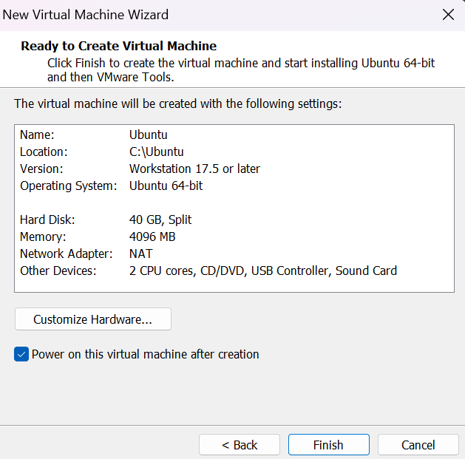
Then, customize the guest OS as required and make sure to select the correct Network Adapter for that Virtual Machine which have been created.
Figure 3. 9: Customizing the Hardware for the Guest OS
Click on “Finish” and virtual machine has been created.
Do the same process for all the virtual machines according to the requirements.

3.5 Installation and Configuration of pfSense Firewall
Follow the steps mentioned above for creation of pfSense firewall. Open the Virtual Machine for pfSense Firewall, it takes some time to load.
As the pfSense setup starts booting, a prompt is displayed with some options and a countdown timer. At this prompt, press 1 for the default installation of pfSense. If any option is not choosen it will start to boot option 1 by default.
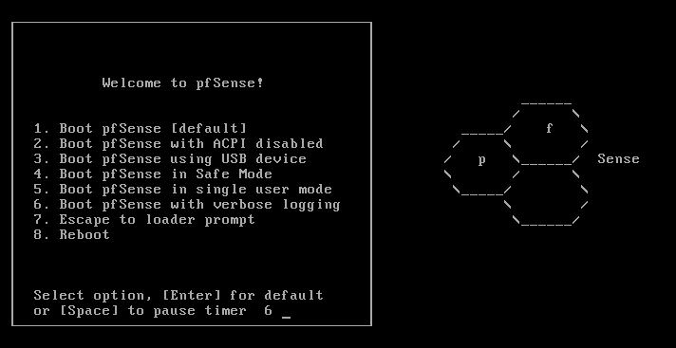
Figure 3. 10: Starting pfSense in VMware
Proceed with the Install option and select OK.
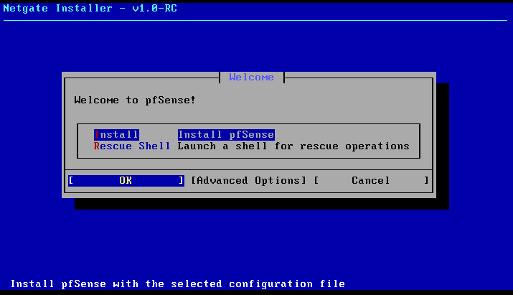
Figure 3. 11: Installing pfSense

Select the WAN Interface.
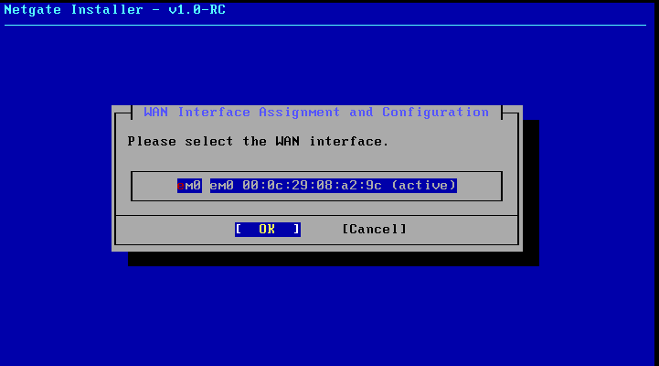
Figure 3. 12: Selecting The WAN Interface
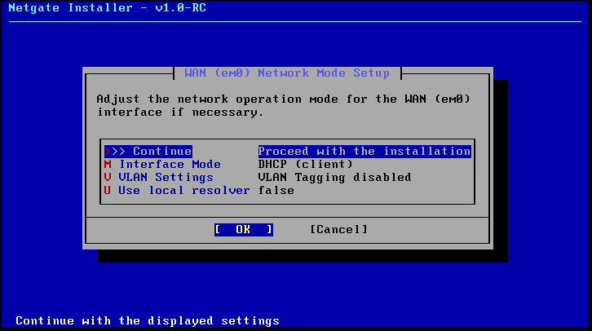
Adjust the network operation mode for the WAN (eM0) interface if necessary. Else, proceed with the installation.
Figure 3. 13: Proceeding With The Installation
Follow the wizard. It will take a few more minutes to complete the setup, obviously depends upon the system resources. Once, the installation process is completed, the following screen is shown.
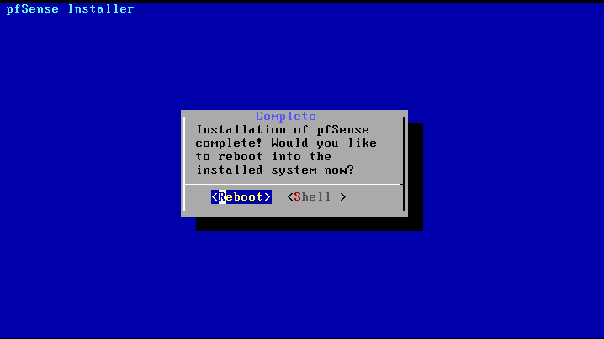
Now, the firewall need to be rebooted by selecting the reboot option.
Figure 3. 14: Rebooting after the installation of pfSense completes
After clicking on the reboot button, we will find that the pfSense firewall is getting a reboot, we will get the pfSense Logo, and finally a Welcome screen the same as per the given image.
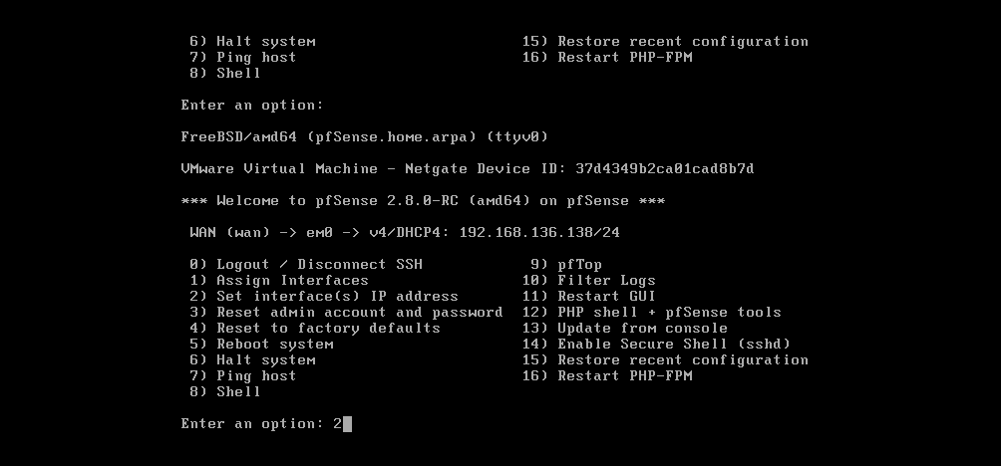
Figure 3. 15: Welcome Screen After Successful Rebooting
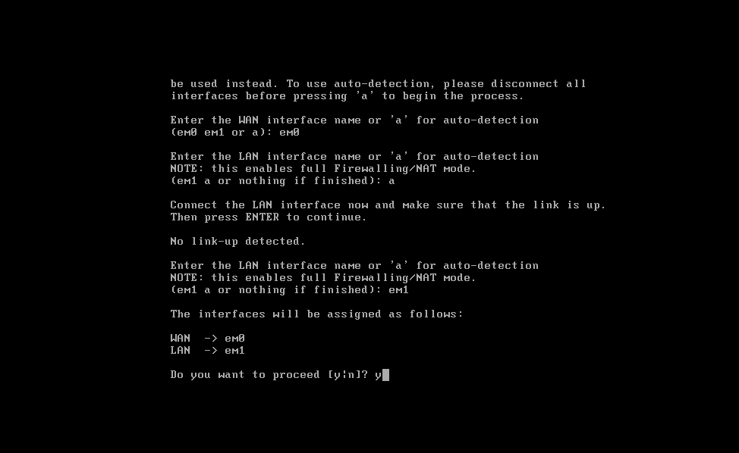
After the installation of pfSense completes successfully, the virtual machine will boot into the initial configuration phase of the setup. In this text-only menu-driven interface, it will allow to configure the initial network configuration so we have connectivity to the pfSense VM.
Figure 3. 16: Confirming the interface configuration in the pfSense initial configuration
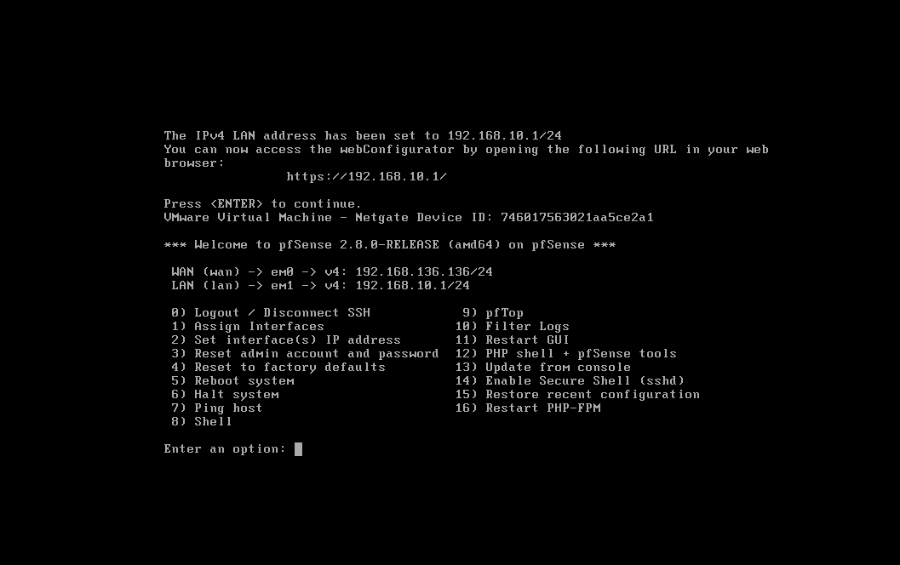
Configure the LAN interface.
Figure 3. 17: Configuring LAN Interface
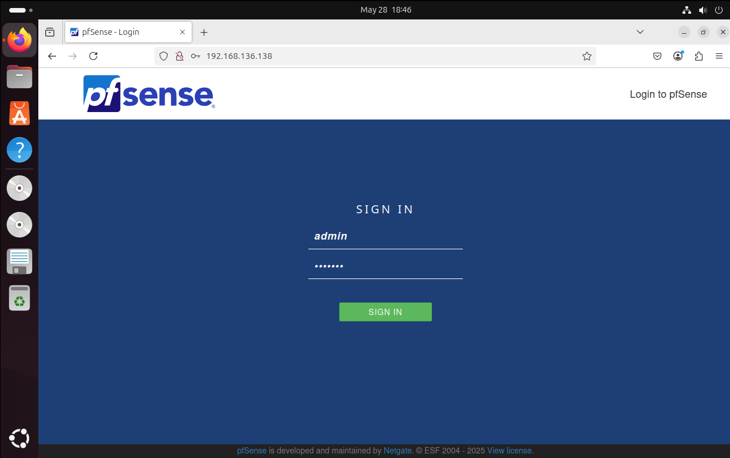
Once pfSense reload, we will be able to access the webConfiguration @ http://192.168.10.1/. The default login user name is admin and the password is pfsense. pfSense setup wizard will guide through the initial configuration of pfSense.
Figure 3. 18: pfSense Login Page
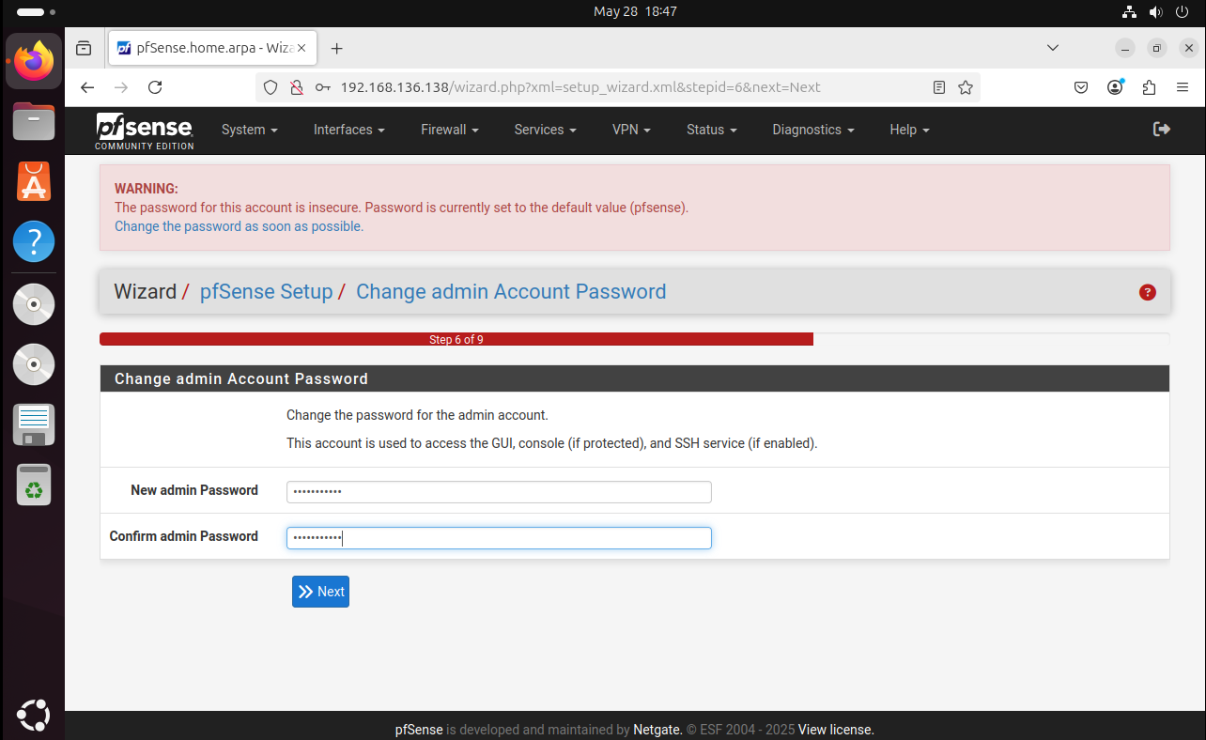
After logging in, pfSense will prompt us to change the default admin password. Make sure to set a strong, secure password to protect the firewall.
Figure 3. 19: Changing Default Admin Password

3.5.1 Configuring Nat: Outbound rule
- Navigate to “Firewall” > “NAT” > “Outbound”.
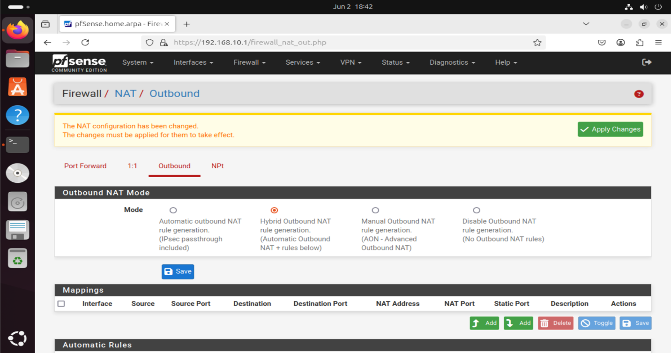
- Set the type from automatic to “Hybrid” and press “Save”.
Figure 3. 20: Selecting the Outbound NAT Mode as Hybrid
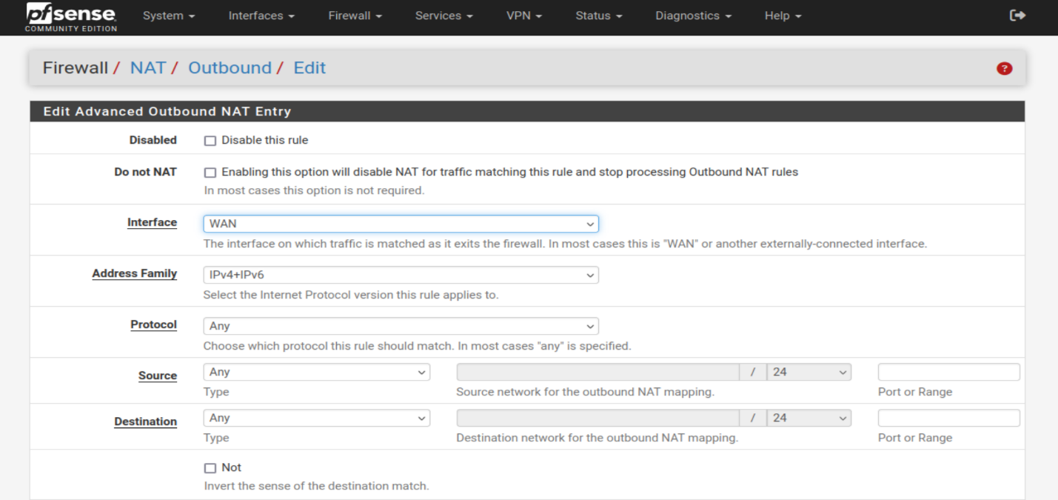
Configure the rule as shown below: IPv4+IPv6, for Any Protocol, source address Any. Check Static Port in the Translation section of the page.
Figure 3. 21: Configuring the Outbound NAT Policy
Here, select the Source as WAN subnets and Destination as the LAN subnets.
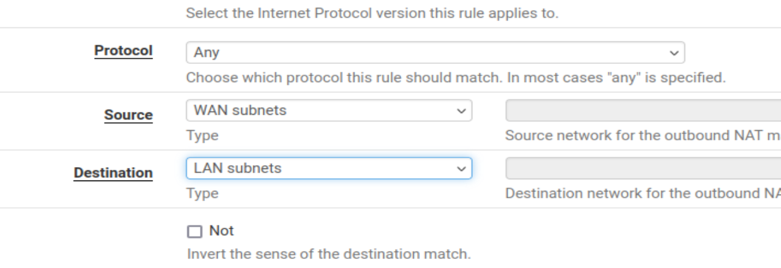
Figure 3. 22: Selecting the Protocol, Source and Destination
Click on Save and the changes will be applied successfully.
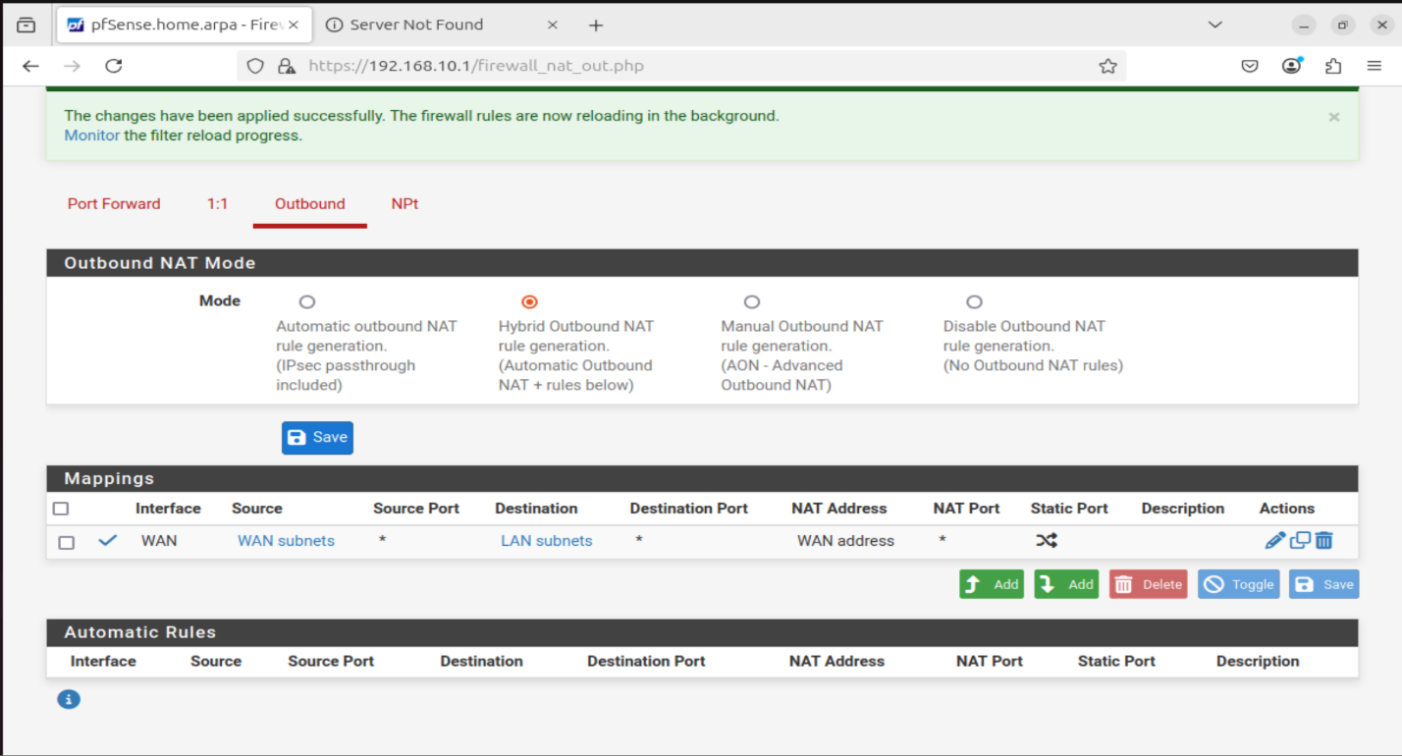
Figure 3. 23: Saving the Changes

3.5.2 LAN Rule
The following screenshot shows the LAN interface firewall rule configured in pfSense. This rule allows internal systems (such as the Wazuh server and the vulnerable host) to communicate with external networks. It is essential for enabling traffic flow from the internal LAN segment to the WAN, including access to update repositories and SIEM log forwarding.
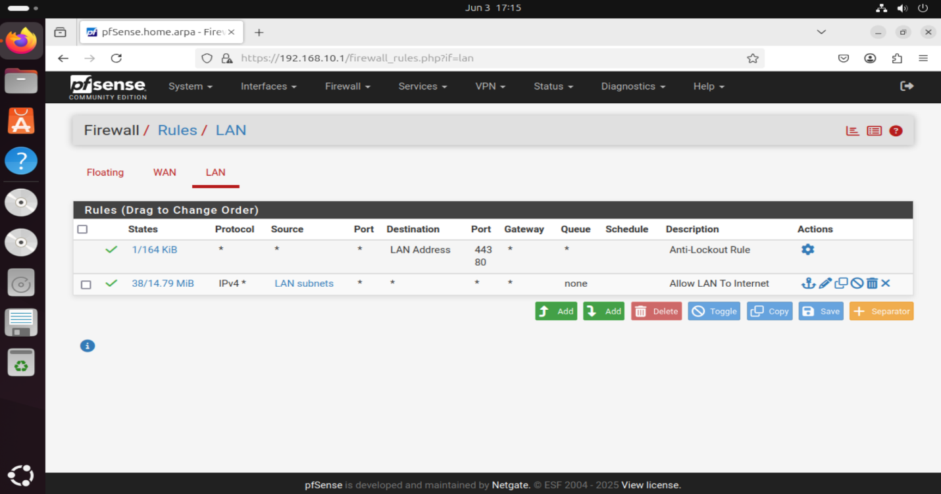
Figure 3. 24: LAN Rule

3.5.3 WAN Rule
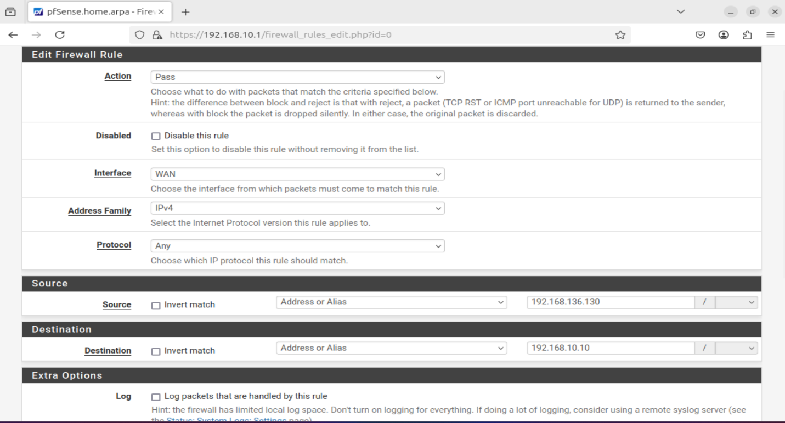
The screenshot shows a pfSense WAN rule that blocks unauthorized access while allowing specific traffic from the Kali attacker machine for testing, preserving a controlled attack surface.
Figure 3. 25: Configuring WAN Rule

3.5.4 Suricata Installation and Configuration on pfSense
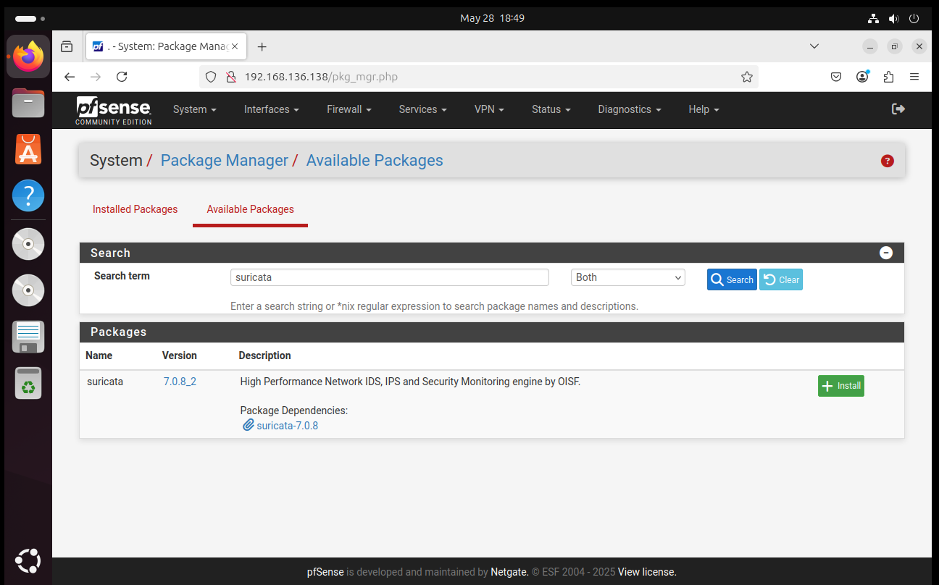
To install Suricata, open the pfSense web interface and go to “System –> Package Manager –> Available “Packages”. The user should enter “Suricata” in the search bar.
Figure 3. 26: Accessing the Package Manager to Find Suricata
Click the Install button and wait for the installation process to complete.
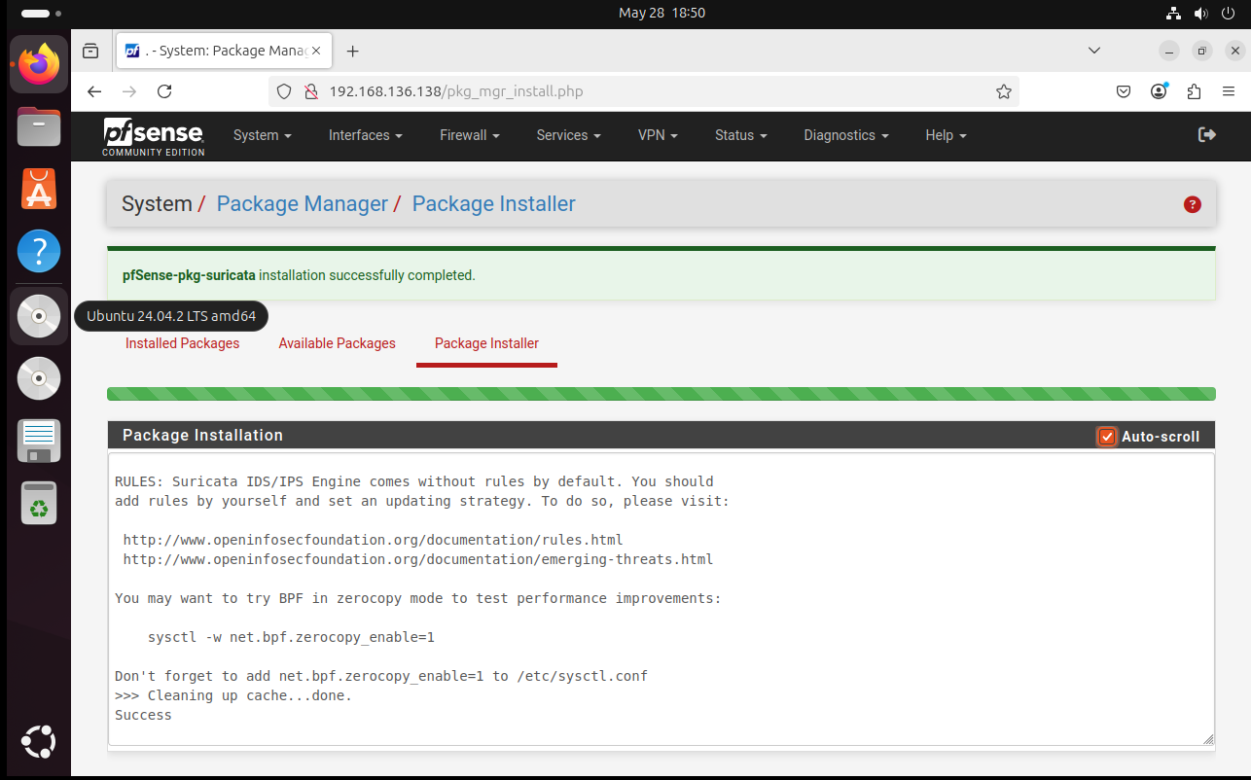
Figure 3. 27: Installing Suricata
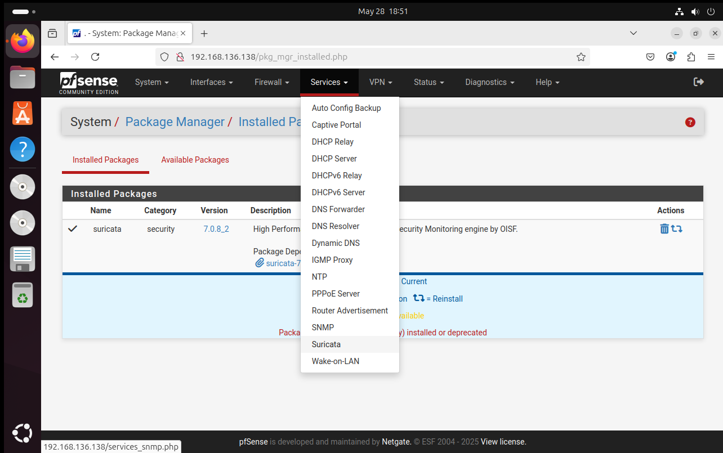
To configure protection for specific interfaces, navigate to Services > Suricata > Interfaces in the pfSense web interface.
Figure 3. 28: Navigating Suricata in the Services Tab
After entering this section, click on Add to reveal several options. Within the WAN Settings area, select the specific WAN interface designated for service activation..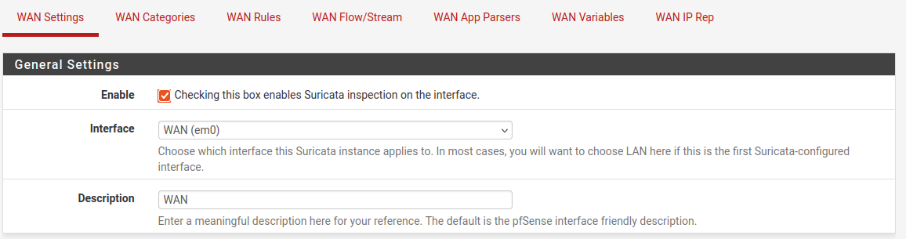
Figure 3. 29: Choosing the WAN Interface
In the logs part select Send Alerts to System Log to send the logs to the firewall and what level.
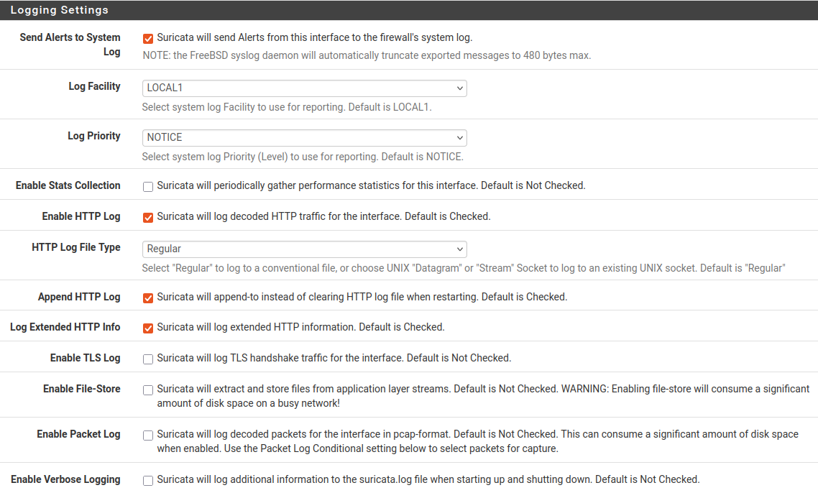
Figure 3. 30: Logging Settings
A very interesting option for the logs is the EVE Output Settings option saving them in json. Similarly, check the other option as required in the EVE Output Settings tab.
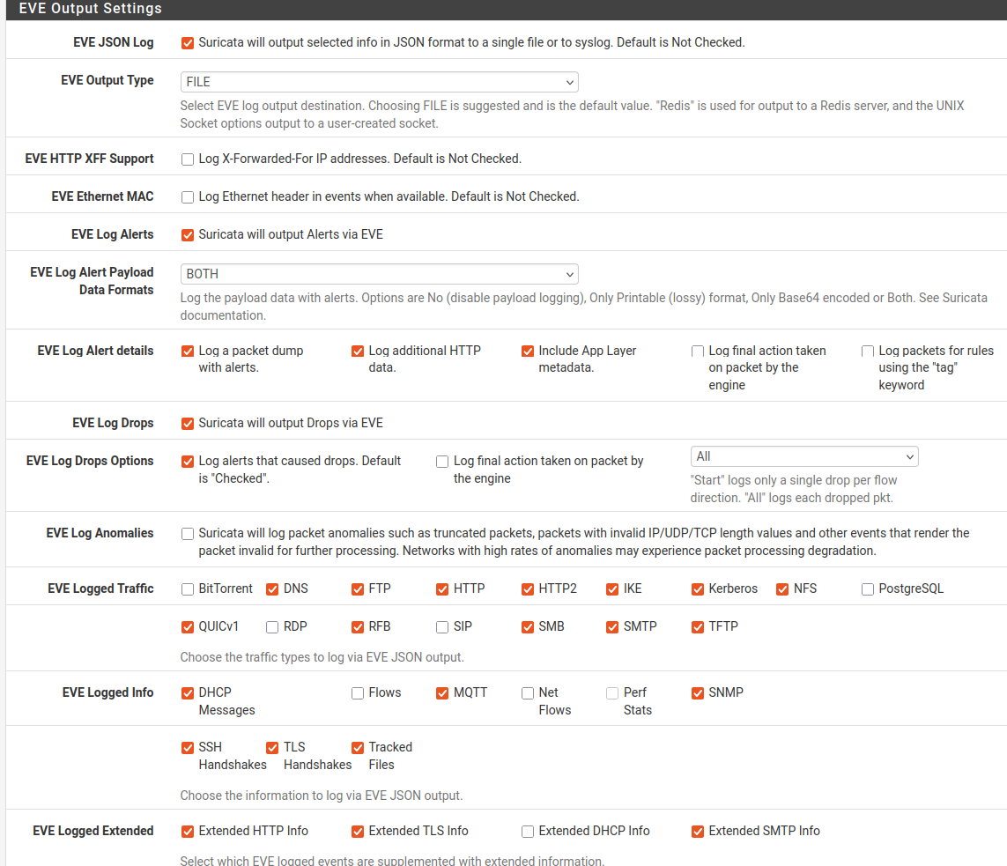
Figure 3. 31: Selecting the Required EVE Output Settings
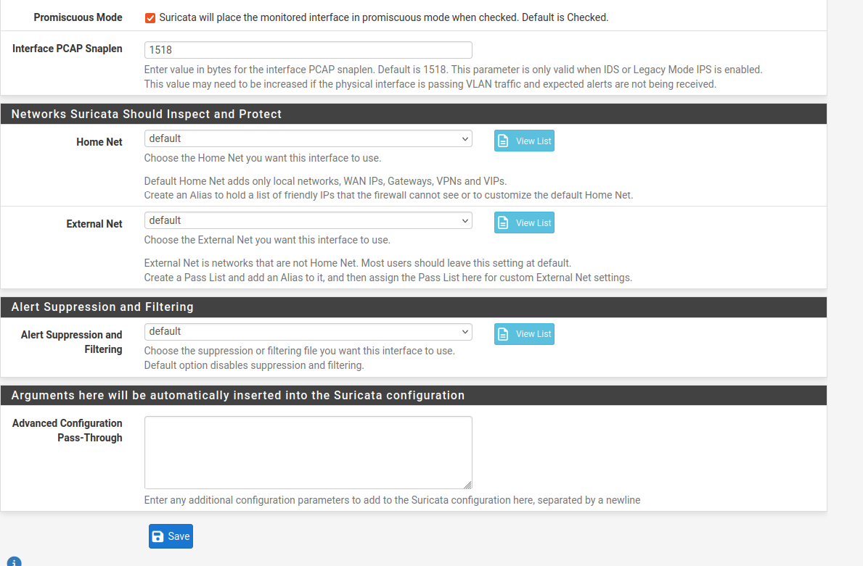
Promiscuous mode is enabled to allow Suricata to inspect all network traffic on the selected interface, while all other settings remain configured with their default values..
Figure 3. 32: Enabling Promiscuous Mode
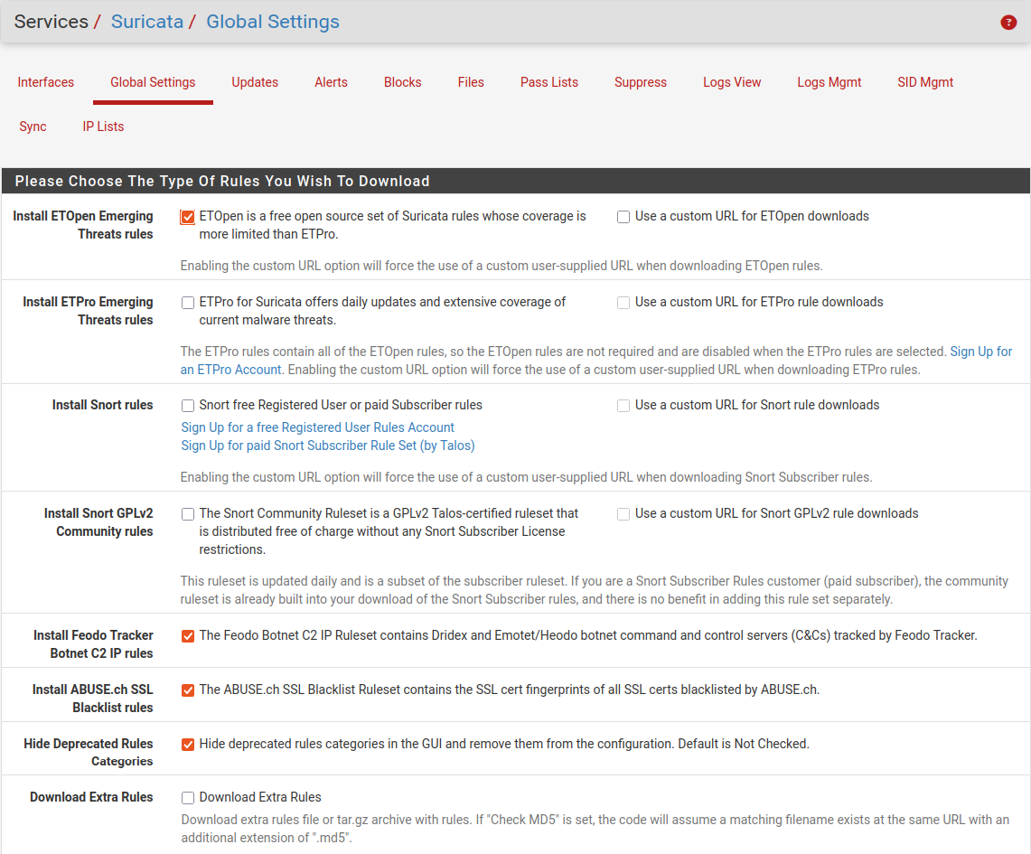
In the Global Settings tab, the desired rule types are selected for download based on the detection needs and threat coverage requirements.
Figure 3. 33: Selecting the Rule Sets
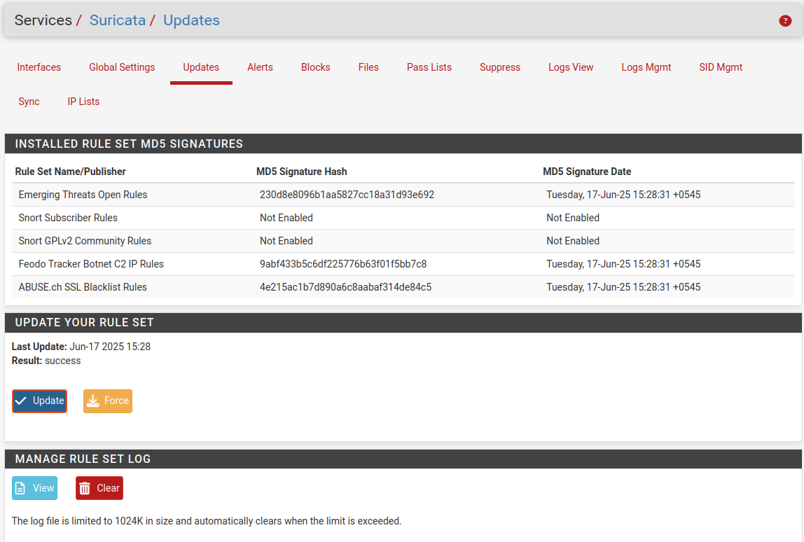
After the rules are added, they can be manually downloaded by navigating to Services > Suricata > Updates and initiating the update process.
Figure 3. 34: Updating the Rule Set
After completing the configuration and saving the settings, Suricata is activated by navigating to Services > Suricata > Interfaces and clicking the play icon corresponding to the desired interface.
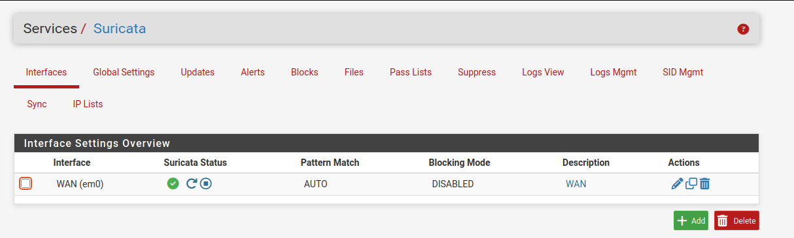
Figure 3. 35: Activating the Suricata

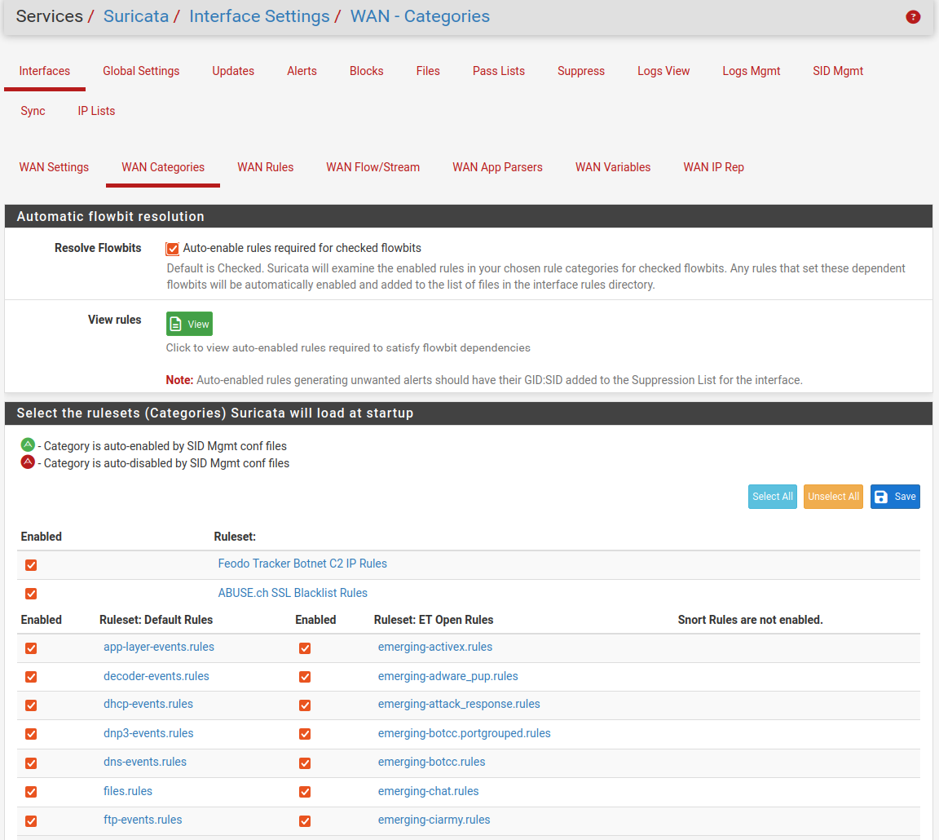
Specific rule categories can be enabled by navigating to Services > Suricata > Interfaces > WAN Categories, where the available categories are listed for selection based on security requirements.
Figure 3. 36: Enabling the Required Rules
After saving the configuration, Suricata is enabled and restarted. The status of the Suricata service can then be verified to ensure it is running correctly.
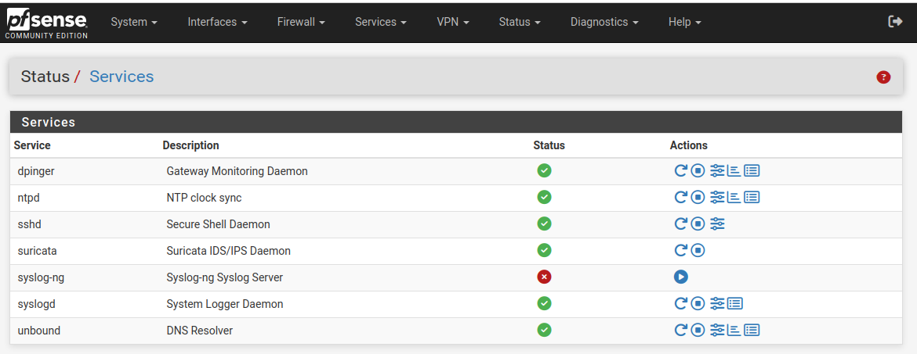
Figure 3. 37: Services

3.5 Installation and Configuration of Wazuh Server in Ubuntu
At first, let us install Ubuntu. Select an appropriate ISO image in the process and install the Ubuntu.
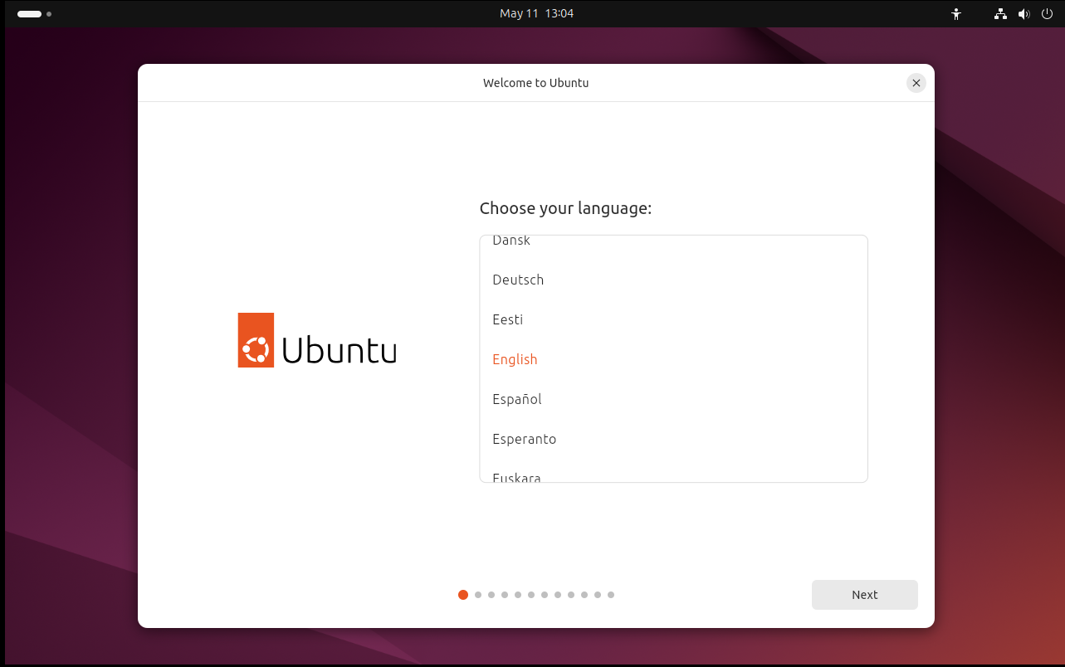
After starting the VM, select a preferred language and then the installation of Ubuntu start.
Figure 3. 38: Selecting the Preferred Language
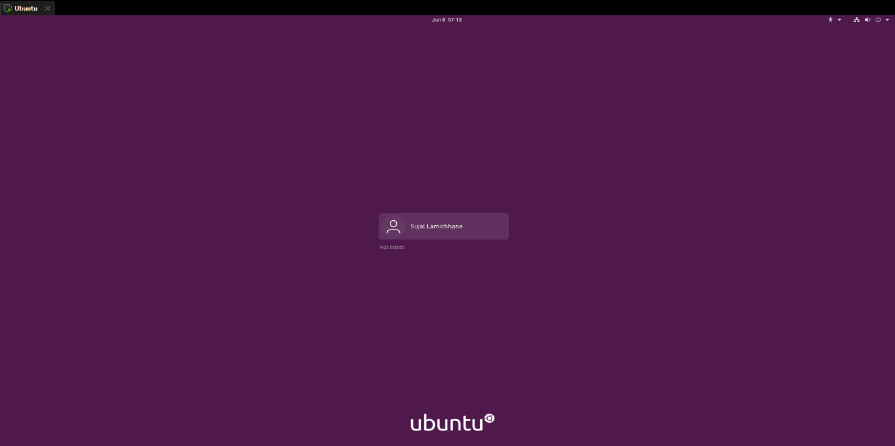
Create the user account and follow the wizard. Wait until it finishes.
Figure 3. 39: Ubuntu OS Login Page
The first step is to upgrade the system.
Once the system is upgraded, Download and execute the Wazuh installation assistant script with the following commands. This script simplifies the installation process, guiding through the setup of Wazuh effortlessly.
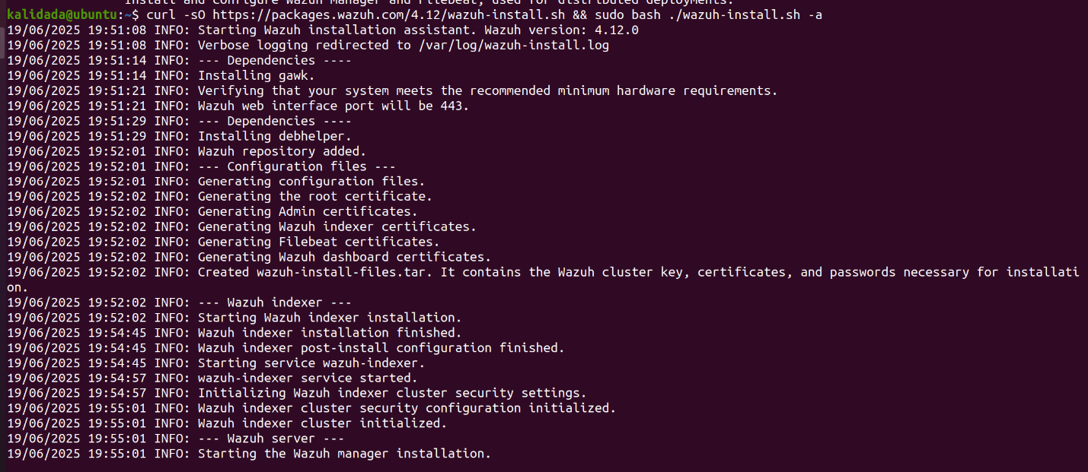
Figure 3. 40: Installing packages
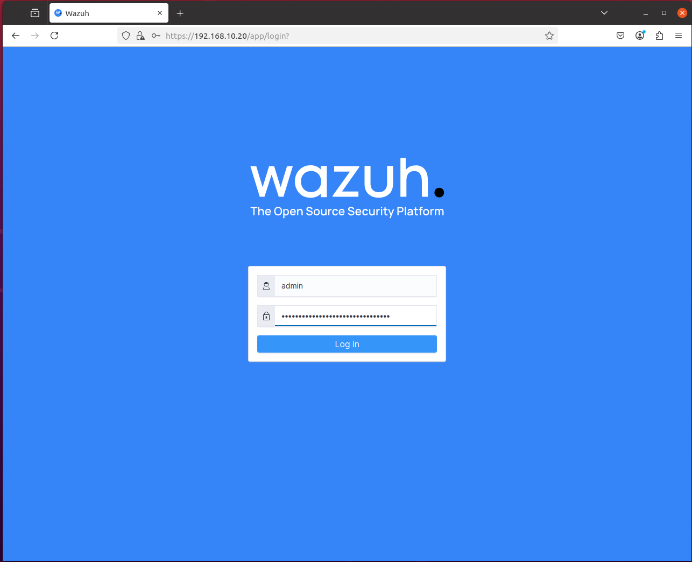
With this, Wazuh server is ready. Copy the provided credentials from the terminal, enter the server IP into the browser, and proceed to login. Navigate to https://192.168.10.20 in the web browser, log in using the provided credentials.
Figure 3. 41: Wazuh Server Login Page
Once the login is successful, Wazuh SIEM dashboard can be explored.
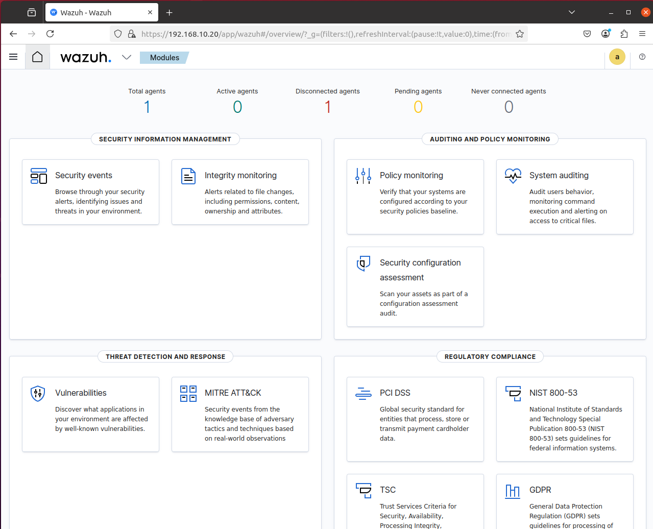
Figure 3. 42: Wazuh Dashboard

3.6 Installing Wazuh Agent in pfSense
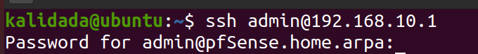
SSH connection from the Ubuntu system is established to the pfSense firewall using its LAN IP address 192.168.10.1. This access is required to perform command-line operations for installing the Wazuh agent directly on pfSense.
Figure 3. 43: SSH connection to pfSense
Successful login will provide the following interface, among them option 8 is choosen to access the pfSense Shell.
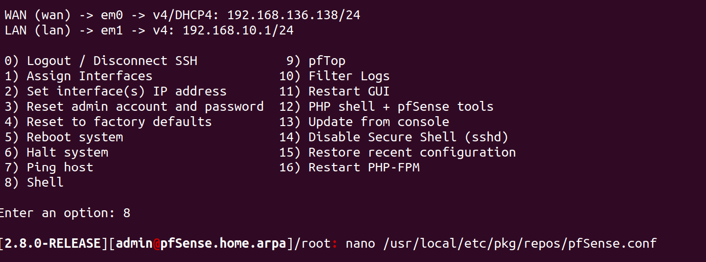
To enable package installation on pfSense, the repository configuration file located at /usr/local/etc/pkg/repos/pfSense.conf needs to be modified. The following screenshot shows the command used to open the file using nano.
Figure 3. 44: Editing the pfSense.conf File
Edit the file /usr/local/etc/pkg/repos/pfSense.conf;
and change the line;
FreeBSD: { enabled: no }
to;
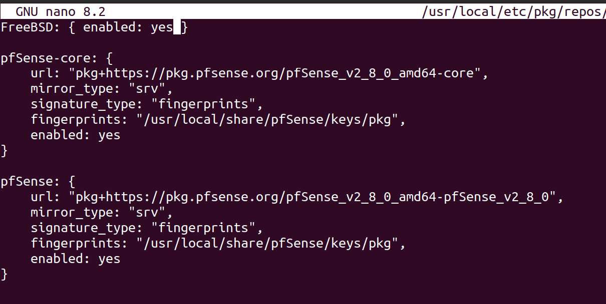
FreeBSD: { enabled: yes }
Figure 3. 45: Enabling the FreeBSD
Once the FreeBSD repositories has been enabled, run the command below to updates package repository catalogues;
pkg update
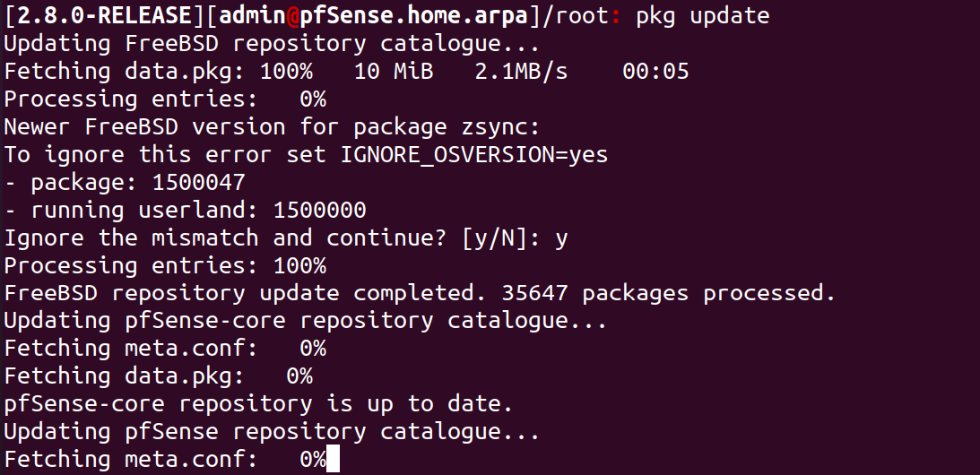
Figure 3. 46: Updating the Package Repository
Wazuh 4.12.0 is the current stable release version. Thus run the command below to check what version is provided by the official FreeBSD repositories;
Figure 3. 47: Checking the Wazuh-Agent Version
Edit the Wazuh agent config file and set the Wazuh manager IP;
nano /var/ossec/etc/ossec.conf
Change the section;
<server>
<address>IP</address>
</server>
to;
<server>
<address>192.168.10.20</address>
</server>
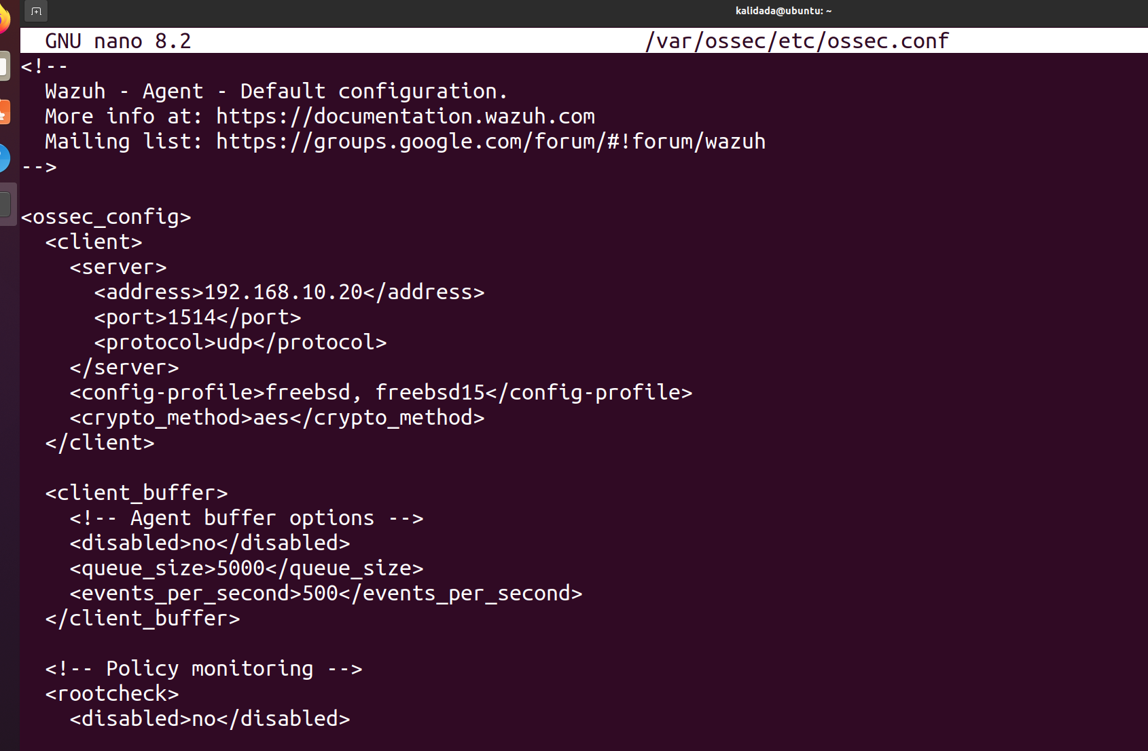
Enable and start Wazuh agent by using the command as shown in the screenshot below;
Figure 3. 48: Editing and Setting Wazuh Manager IP
Figure 3. 49: Enabling and Starting Wazuh Agent
The use of FreeBSD official repositories on pfSense can now be disabled.
Figure 3. 50: Opening pfSense.conf File using Nano
Figure 3. 51: Opening FreeBSD.conf File using Nano
Change the line;
FreeBSD: {enabled: yes}to; FreeBSD: {enabled: no}
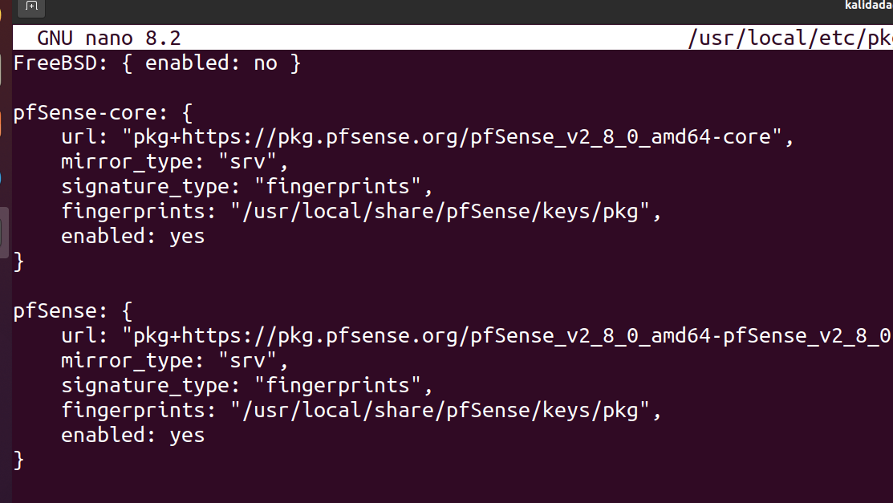
Update package catalogue;
Figure 3. 52: Disabling FreeBSD Official Repositories
pkg clean all
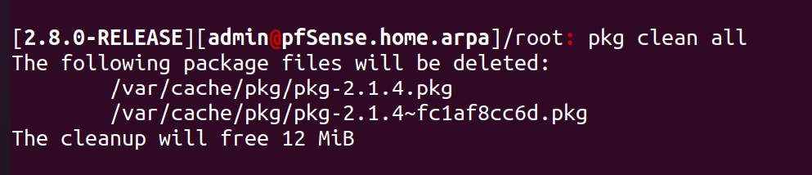
pkg update
Figure 3. 53: Cleaning Package Catalog

3.6.1 Confirm pfSense Wazuh Agent Status on Wazuh Manager
Login to Wazuh manager interface and confirm the pfSense agent status;
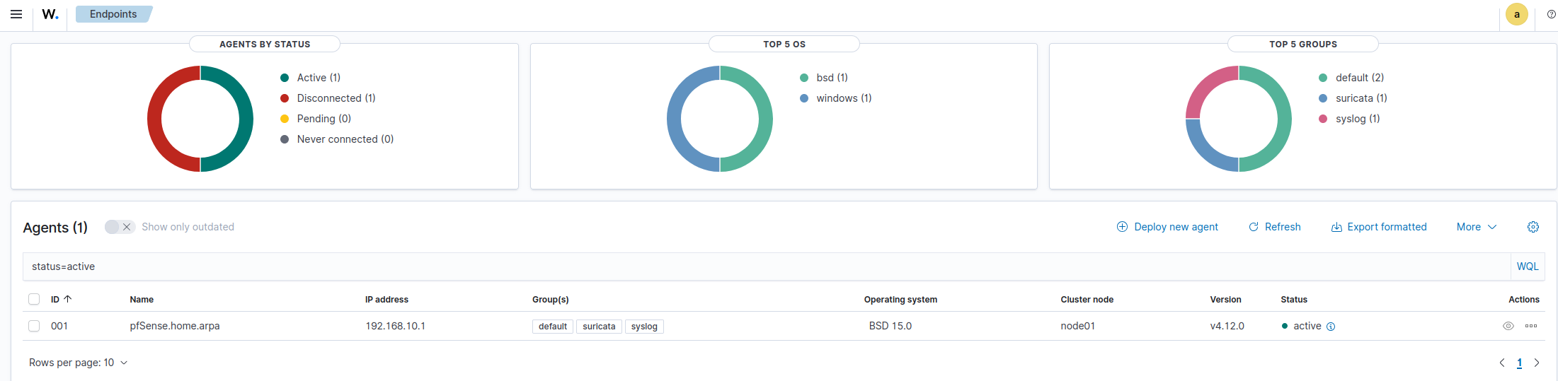
Figure 3. 54: Confirming Wazuh Agent Status in Manager
pfSense Wazuh agent (pfSense.home.arpa) is connected to the Wazuh server and is up and running.

3.7 Installing Wazuh Agent in Windows (Vulnerable System)
The Wazuh agent monitors Windows systems and communicates with the Wazuh server in near real-time through an encrypted and authenticated channel.
Download the Wazuh agent Windows installer and save the installer on the Windows endpoint.
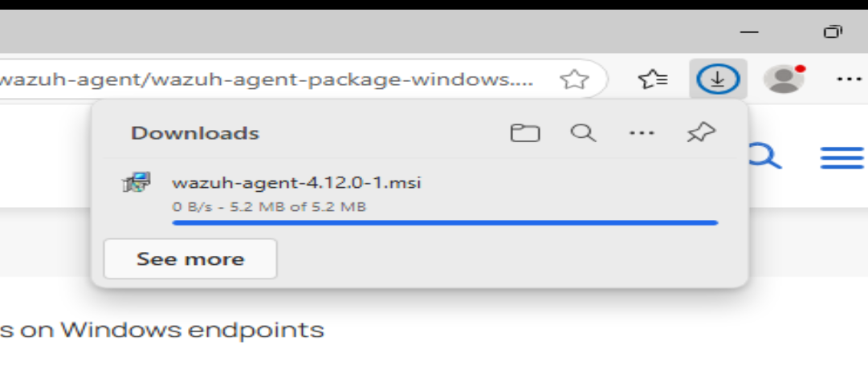
Figure 3. 55: Downloading Wazuh Agent
Wazuh agent installation can be performed using either the Command Line Interface (CLI) or Graphical User Interface (GUI). Open the powershell as a Administrator and execute the command.
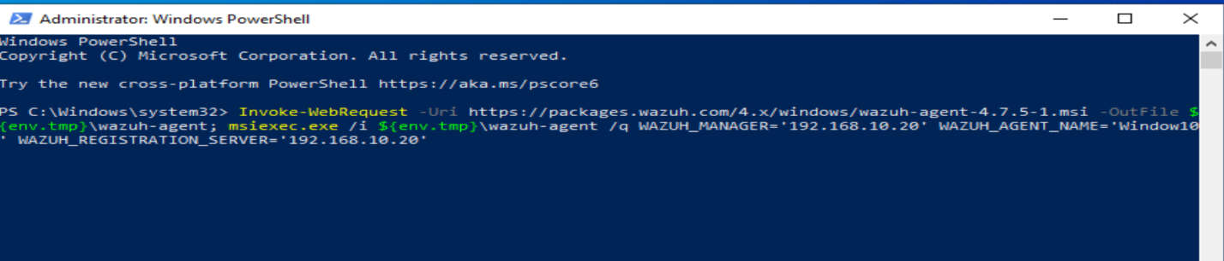
Figure 3. 56: Executing the Command to Install the Package
After installation, the Wazuh agent service must be started to begin monitoring.
Open CMD or PowerShell and run:
NET START Wazuh
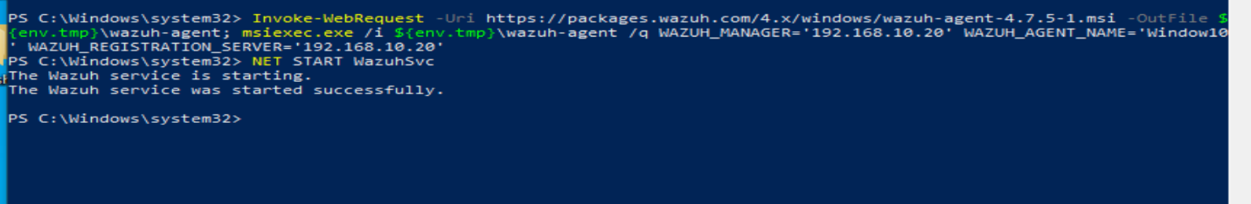
Figure 3. 57: Starting the Wazuh Agent Service
The Wazuh agent is now successfully installed and configured on the Windows endpoint. It communicates securely with the Wazuh server, sending critical monitoring data.
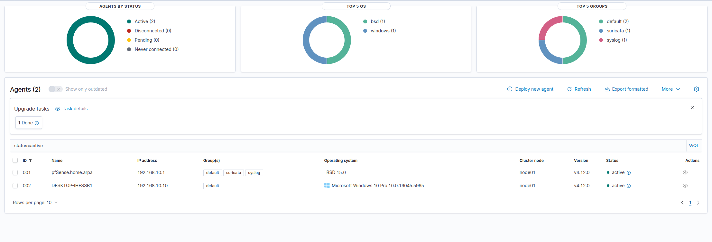
Figure 3. 58: Agent Successfully Connected to the Manager

3.8 Installing shuffle SOAR
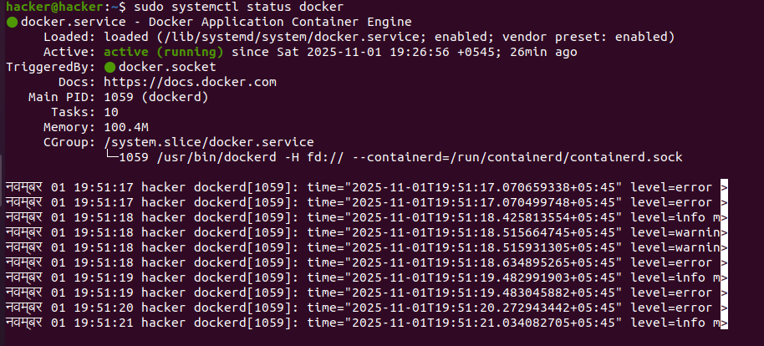
To install Shuffle SOAR, first ensure Docker and Docker Compose are installed on the system.
Figure 3. 59 Docker and Docker Compose Active
Then clone the official Shuffle repository from GitHub using:
git clone https://github.com/shuffle/Shuffle
Move into the cloned repository folder:
cd Shuffle
Run the following command to build and start all Shuffle services:
docker-compose up –d
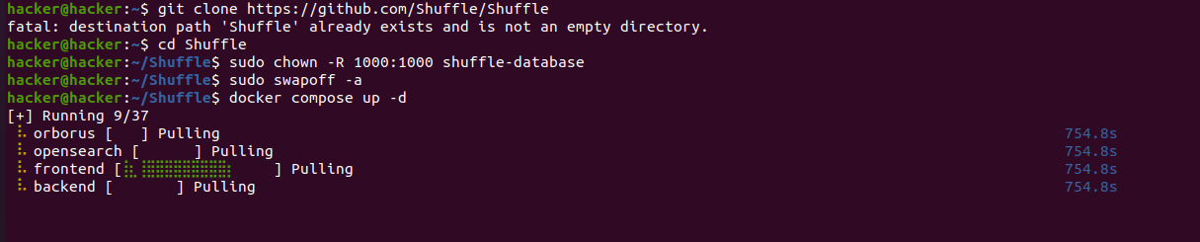
The above output confirms that Shuffle SOAR has been successfully started using the docker compose up -d command. All required containers shuffle-orborus, shuffle-opensearch, shuffle-backend, and shuffle-frontend are running successfully.
Figure 3. 60 Docker Compose Installing
Figure 3. 61 Docker Compose Running
This screen shows the Shuffle SOAR login page for a self-hosted installation. Users can log in using their username and password to access the Shuffle platform.
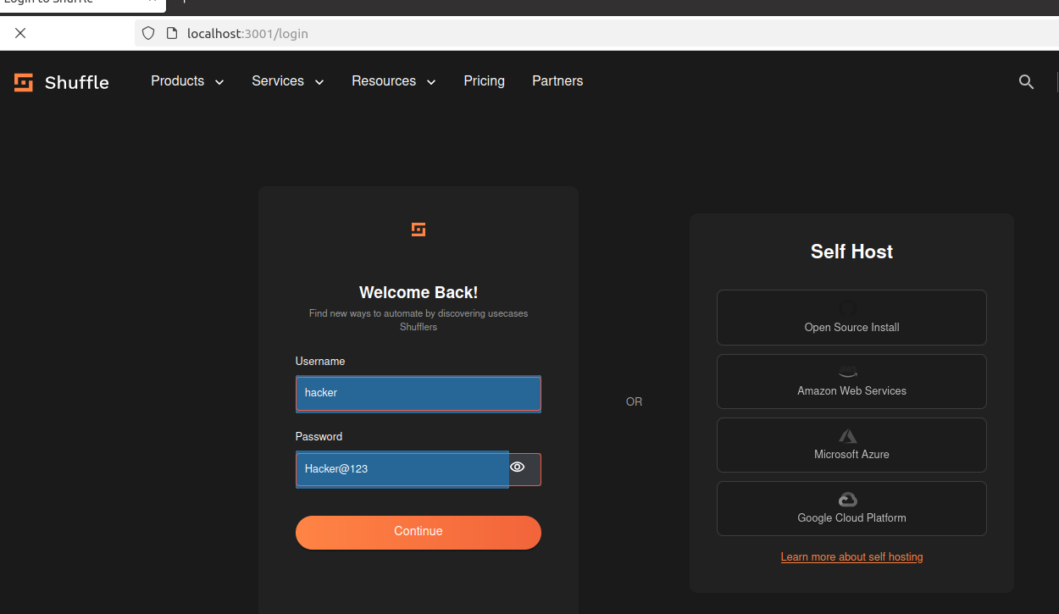
Username= hacker, Password=Hacker@123
Figure 3. 62 Shuffle SOAR Login Page
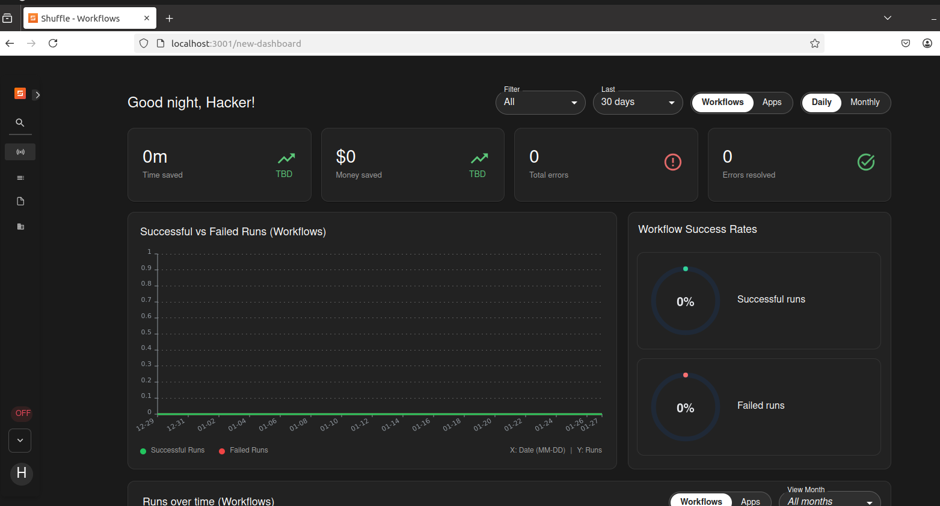
This screen shows the Shuffle SOAR dashboard, confirming that the platform is running successfully. The charts will automatically update once workflows are create and run.
Figure 3. 63: Shuffle Dashboard

3.9 MISP Installation and Configuration
MISP runs on port 443 by default, so no port needs to be specified. Navigate to the IP address to reach the login screen. Log in with admin@admin.test / admin, then immediately change the default password.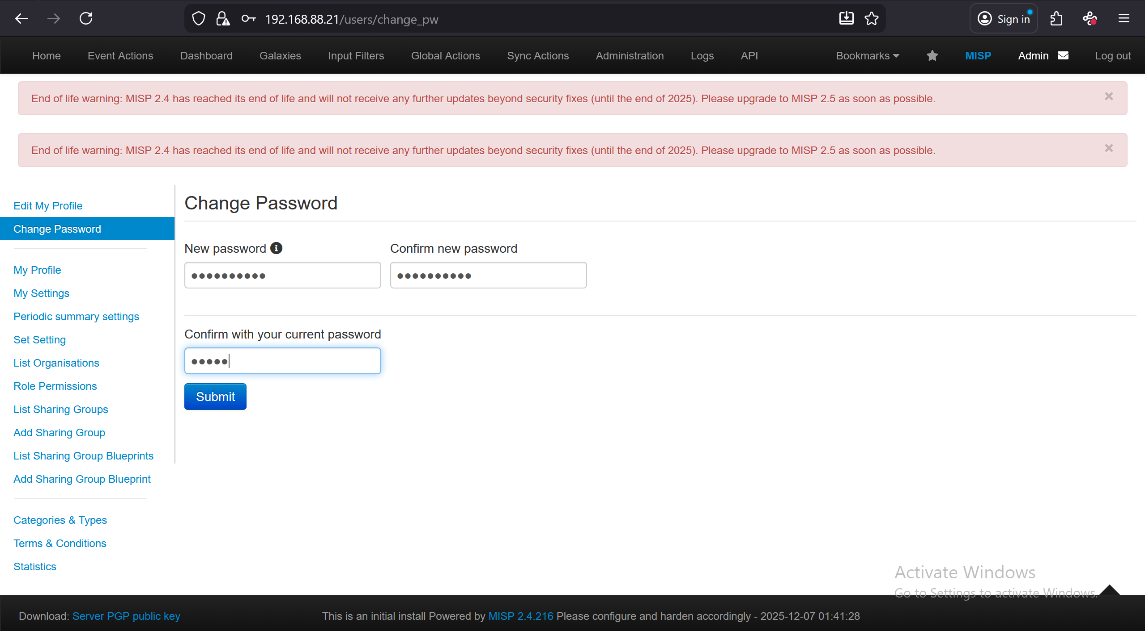
Figure 3. 64: Changing Default Password
Now we need to add a new organization to MISP, so navigate to the administration tab and select add organization.
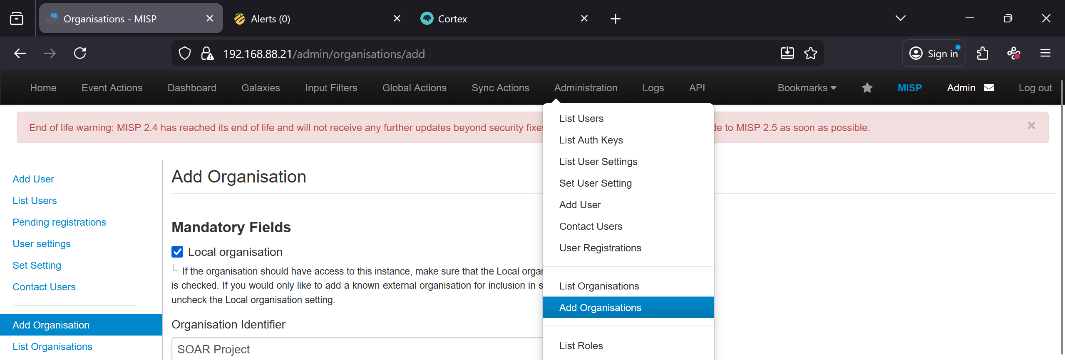
Figure 3. 65: Adding New Organization

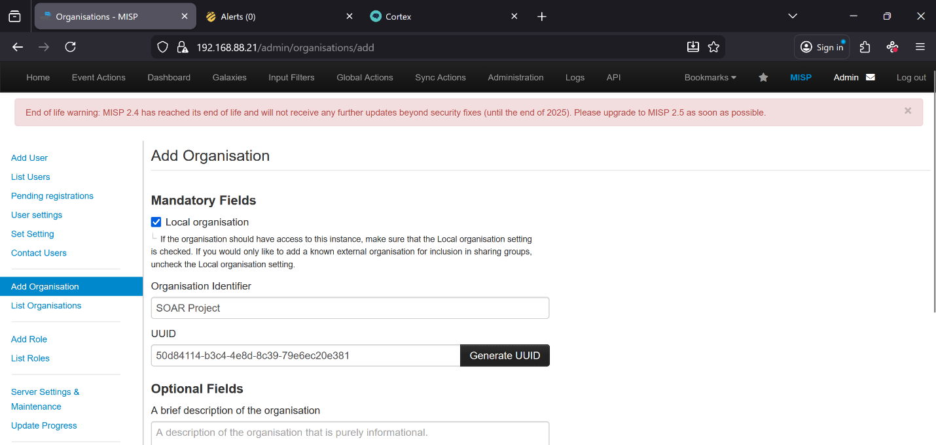
All we need to worry about here is giving our organization an identifier and generating a UUID, here we have provided the organization name as “SOAR Project”.
Figure 3. 66: New Organization
Now we need to add a user and tie that user to our new organization, head back to the administration tab and select add user.
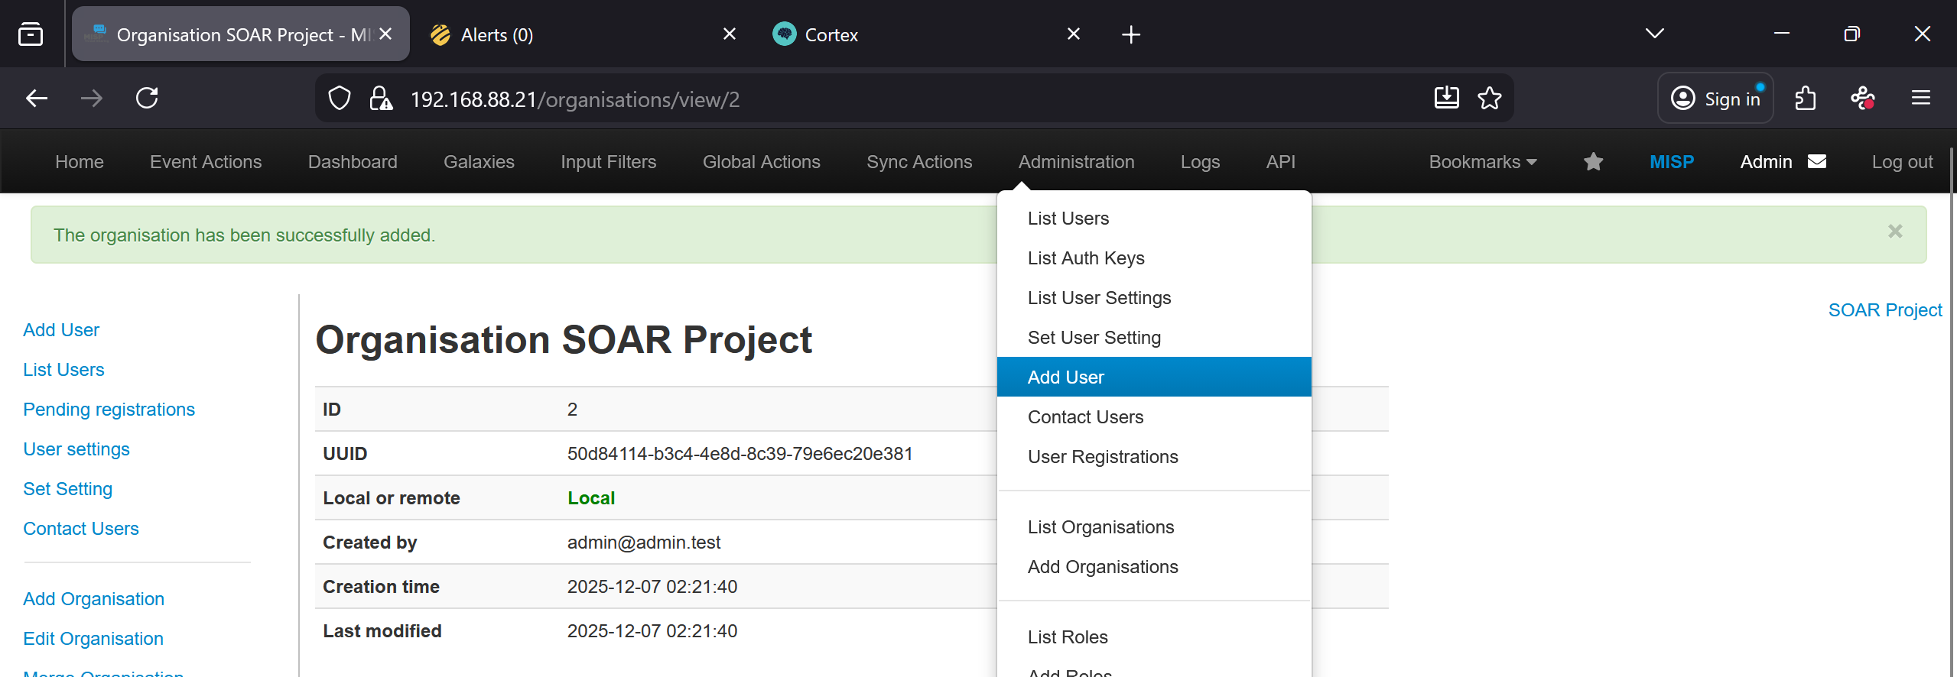
Figure 3. 67: Adding New User

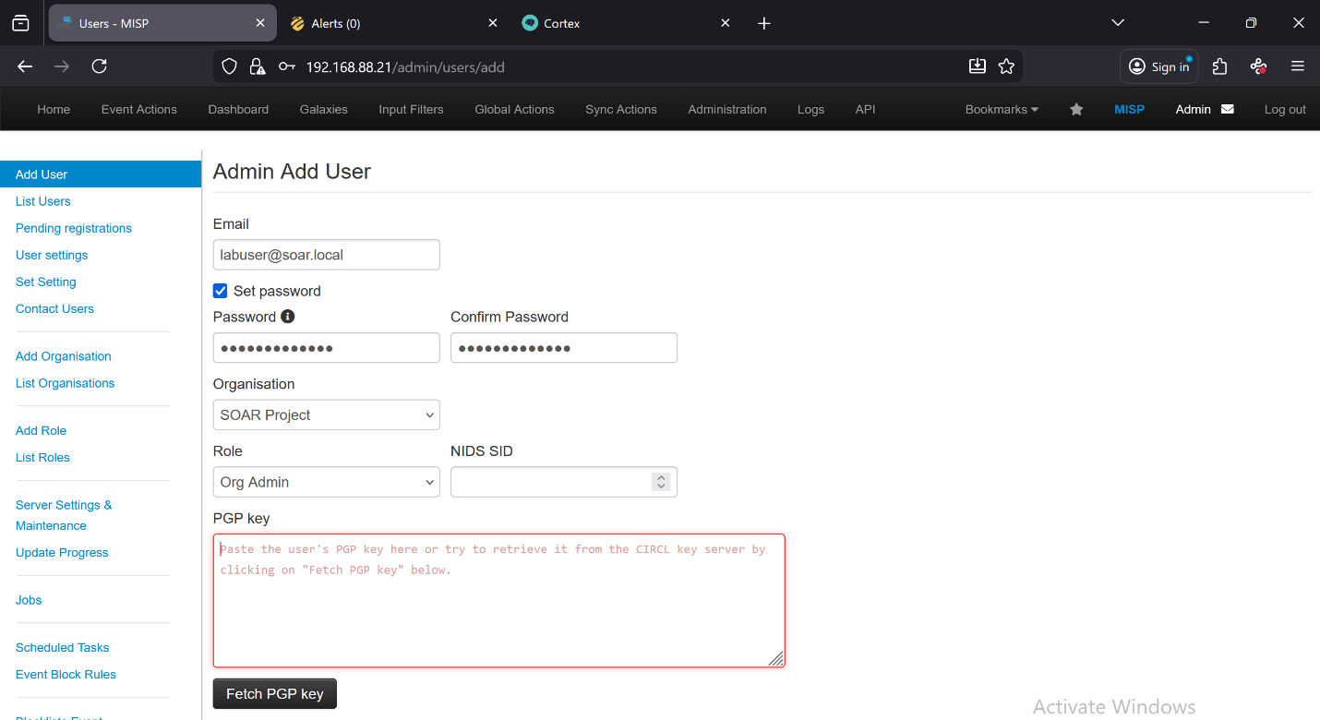
You can set a fake or real email here, up to you. Make sure you set a password, assign the user to your new organization, and set the Role to Org Admin.
Figure 3. 68: Assigning User to The New Organization
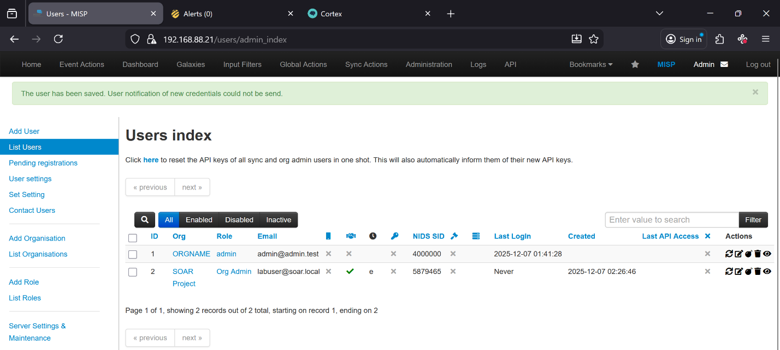
In order to link MISP to The Hive, we’ll need an auth key, so head over to the actions section and click the eye icon to view our new user.
Figure 3. 69: Users Index

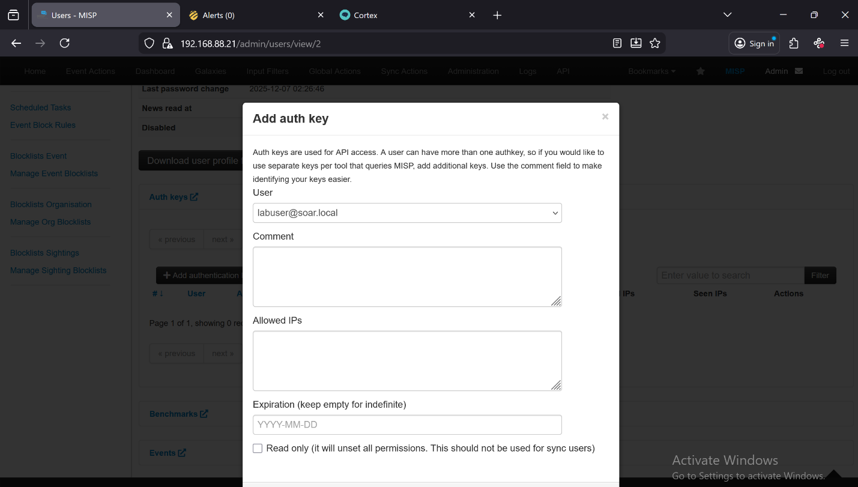
Scroll down to Auth keys and click the link. Select Add authentication key, then in the pop-up window simply click Submit without changing anything.
Figure 3. 70: Creating Auth Key
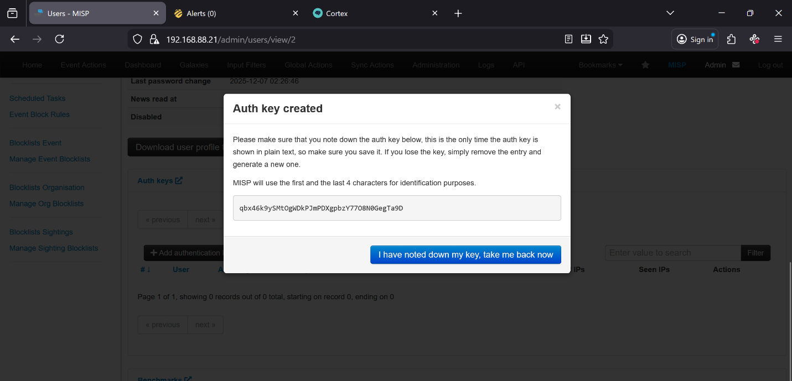
Now we have our Auth key!
Figure 3. 71: Created Auth Key

3.10 Cortex Setup and Configuration
Now we need to set up Cortex, change the port number to 9001 and access it using http://<IP>:9001 and head to the login screen.

Figure 3. 72: Updating Cortex Database
We will be prompted to create our administrator account. Go ahead and log into the account created. We need to set up Cortex similarly to MISP, so first we need to create an organization.
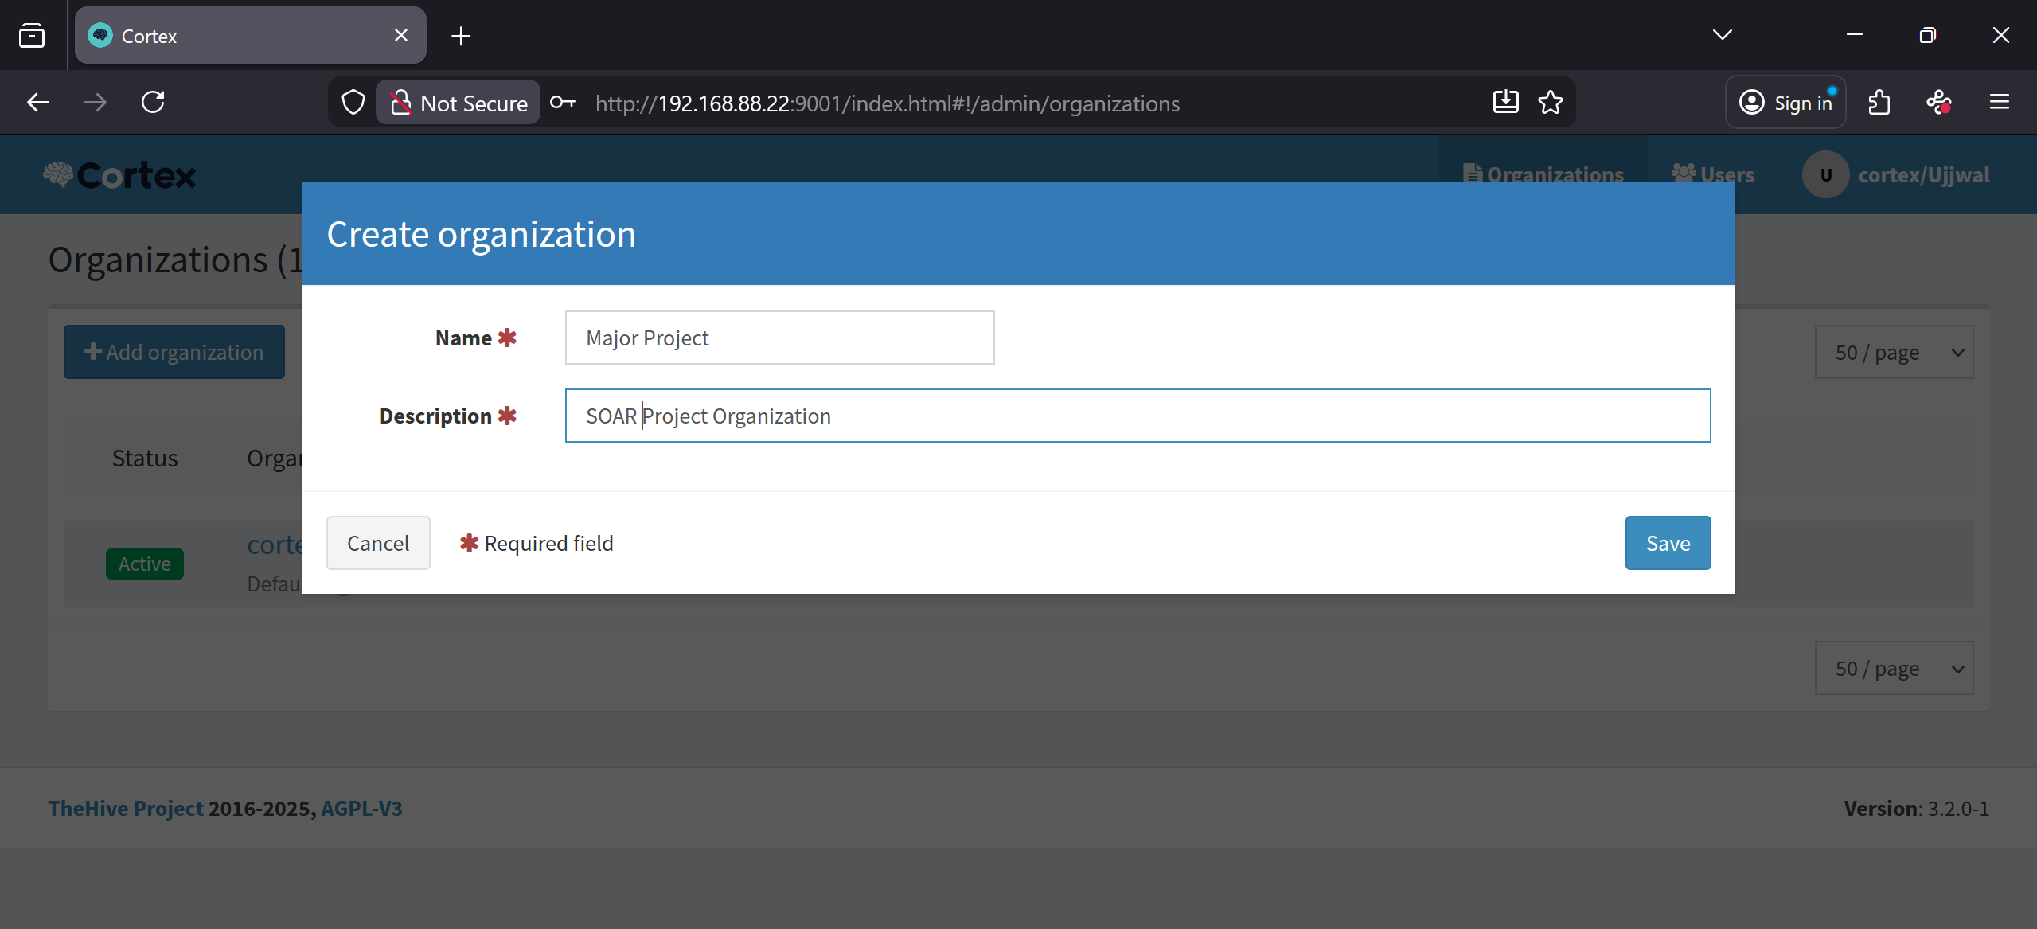
Figure 3. 73: Creating New Cortex Organization
Now navigate to the user section. click “Add User”.
Fill in the required sections and save your new user. Make sure to specify the new organization you created and assign the “read, analyse, orgadmin” role to the user.
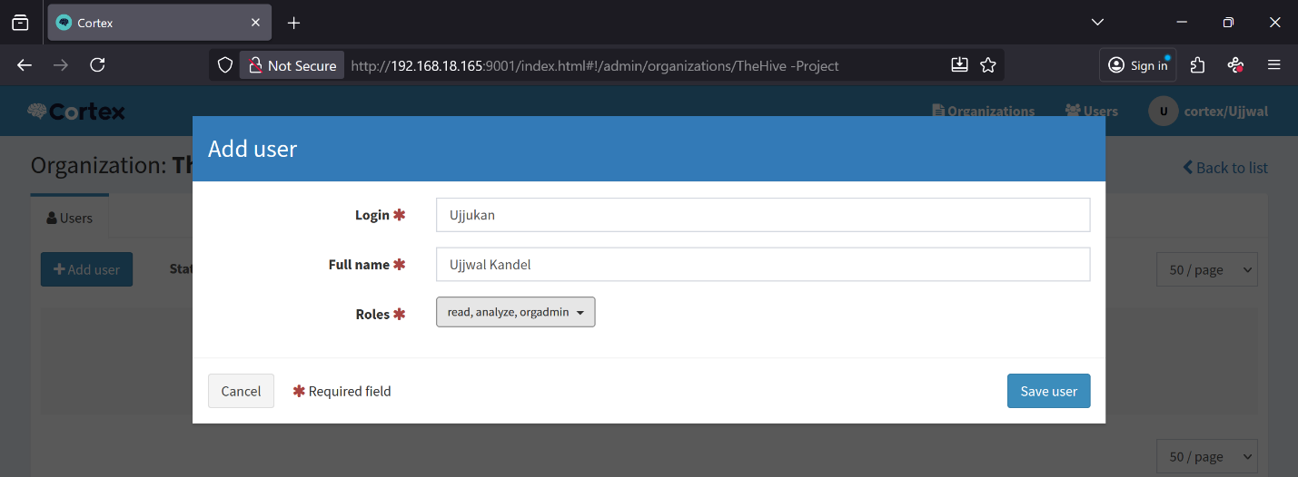
Figure 3. 74: Adding New User
Set a password for the new user and create an api key.
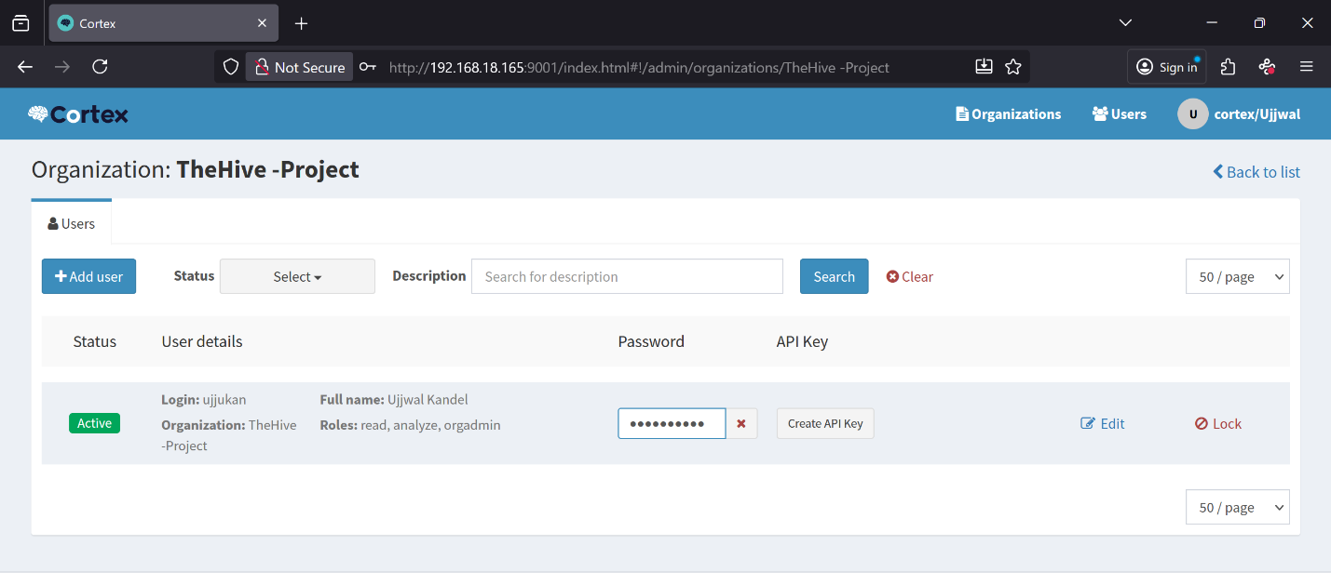
Reveal the api key and save it with the MISP key we created earlier.
Figure 3. 75: Setting Password

3.11 The Hive Configuration
Time for The Hive, access it using http://<IP>:9000, the initial login credentials are username: admin password: secret
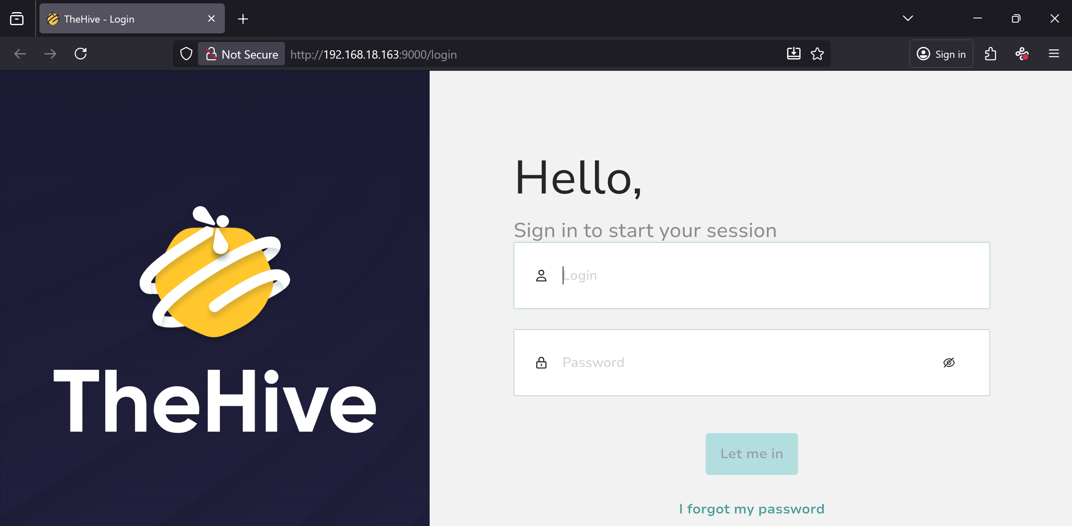
Figure 3. 76: TheHive Login Page
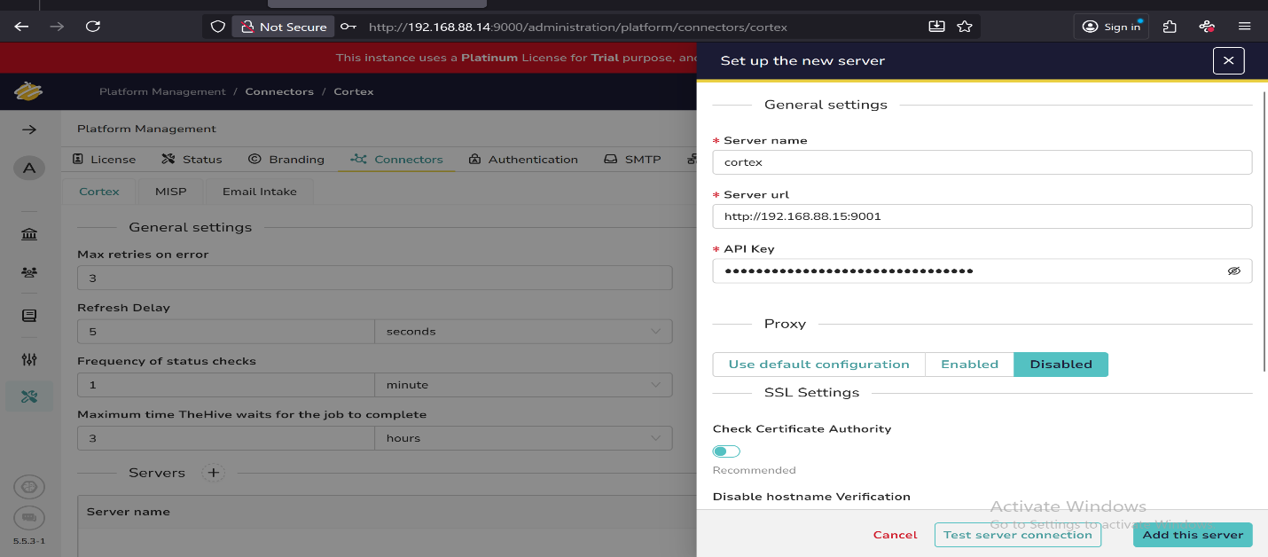
Head over to the Platform Management section. Click on the Cortex section. Scroll down and select the Cortex server. Change the URL to our IP address and paste in the api key we created earlier. Make sure to uncheck “Check Certificate Authority” as we are using an internal cert and The Hive won’t be a fan of that.
Figure 3. 77: Integrating Cortex with TheHive
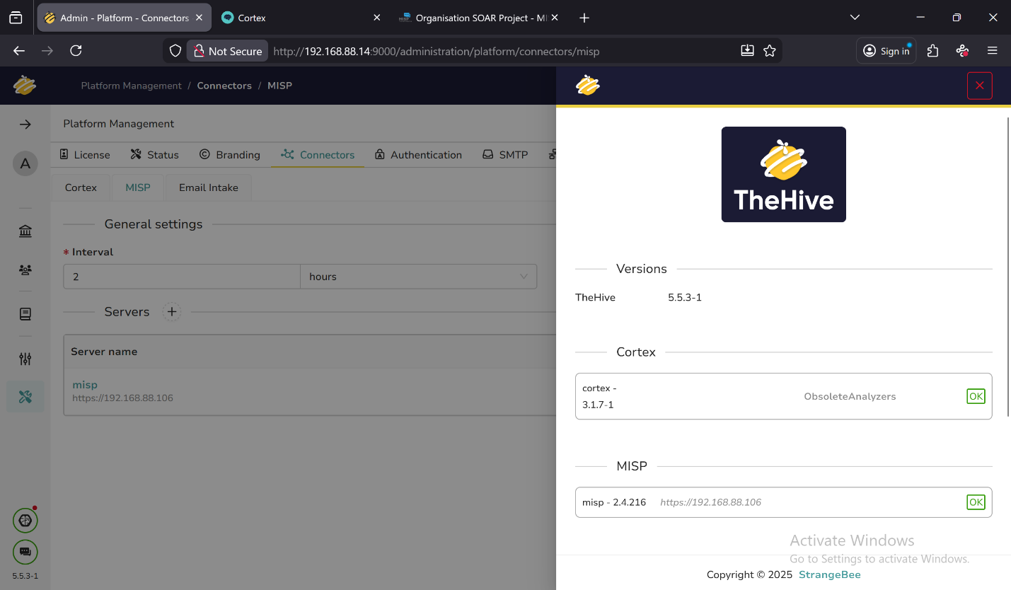
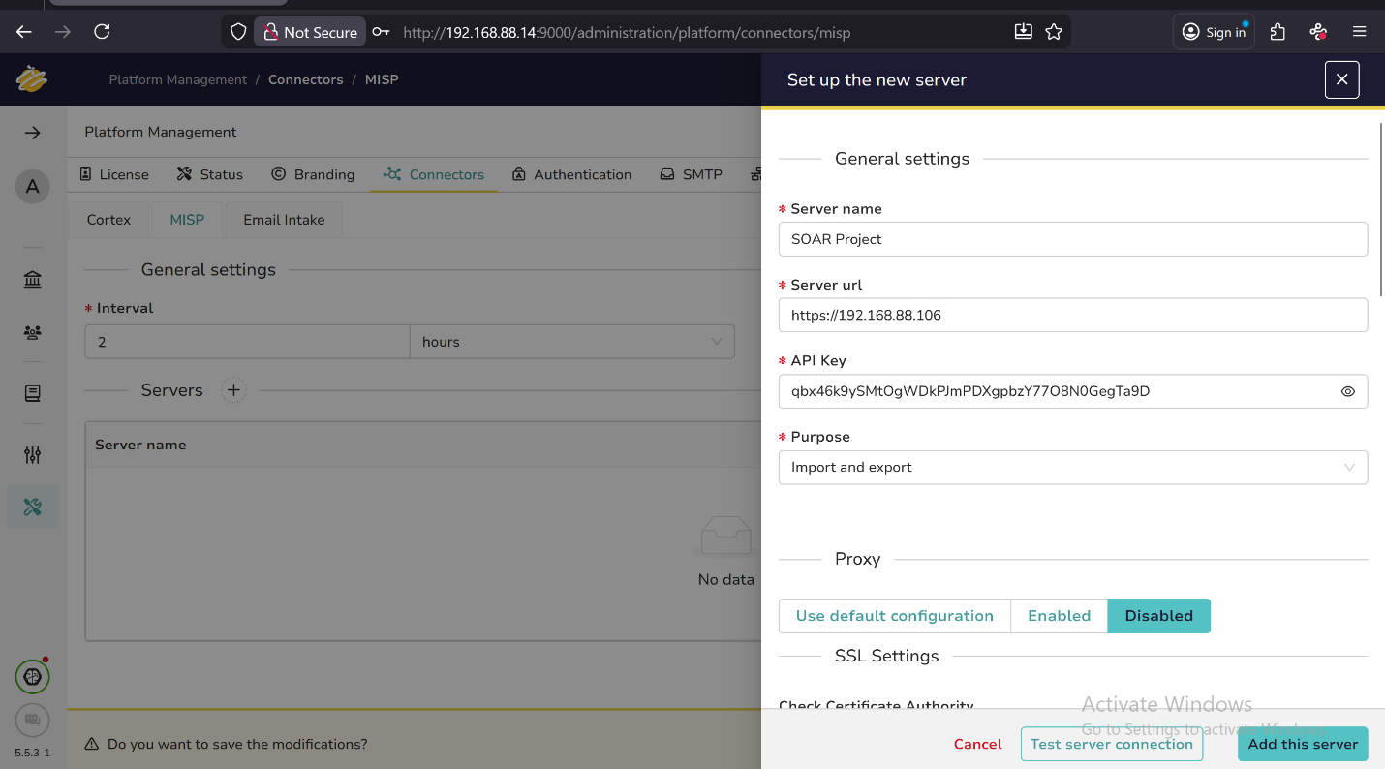
Again, navigate to the MISP section and click the add icon. Input the required info and paste in the auth key we created earlier. Same thing here, uncheck ‘Check Certificate Authority’.
Figure 3. 78: Successful Integration of Cortex and MISP
Figure 3. 79: Integrating MISP with TheHive
Lastly, we need to set up an organization and a user like we’ve done with Cortex and MISP.
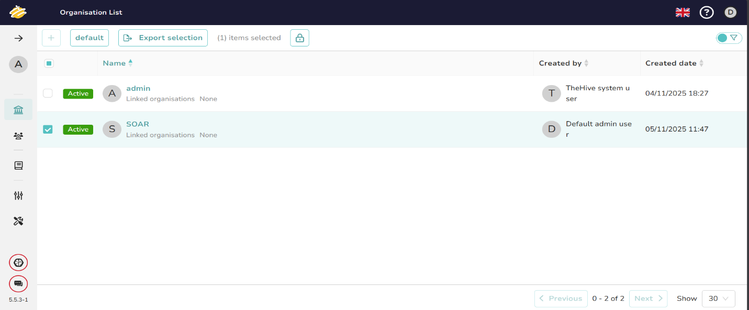
Click on the Organization tab then click the plus icon to make a new org. Nothing too crazy here. Give org a name and brief description, the last two rules can be left as ‘manual’. Here, our organization named “SOAR” is successfully created.
Figure 3. 80: Created Organization
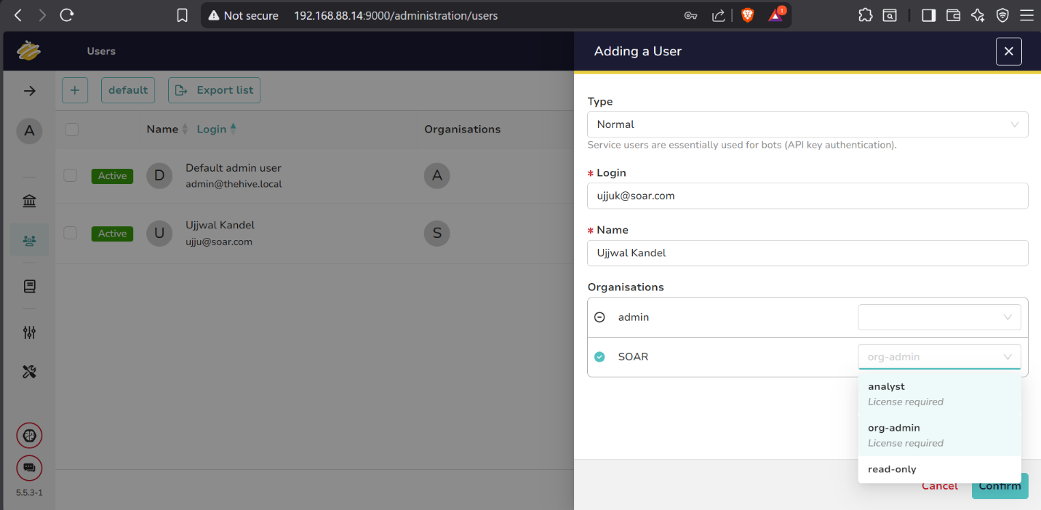
Now we’ll add a user to the new organization. click the user tab and then the plus icon. Keep the type as default, fill in the name login and name fields, select your new organization and give the user org-admin privileges.
Figure 3. 81: Creating New User
Hover mouse cursor over the new user and we will see a ‘Preview’ button, click that to open user settings. Scroll down until you see the option to set a password, then go ahead do just that. And with that, initial configuration is done!
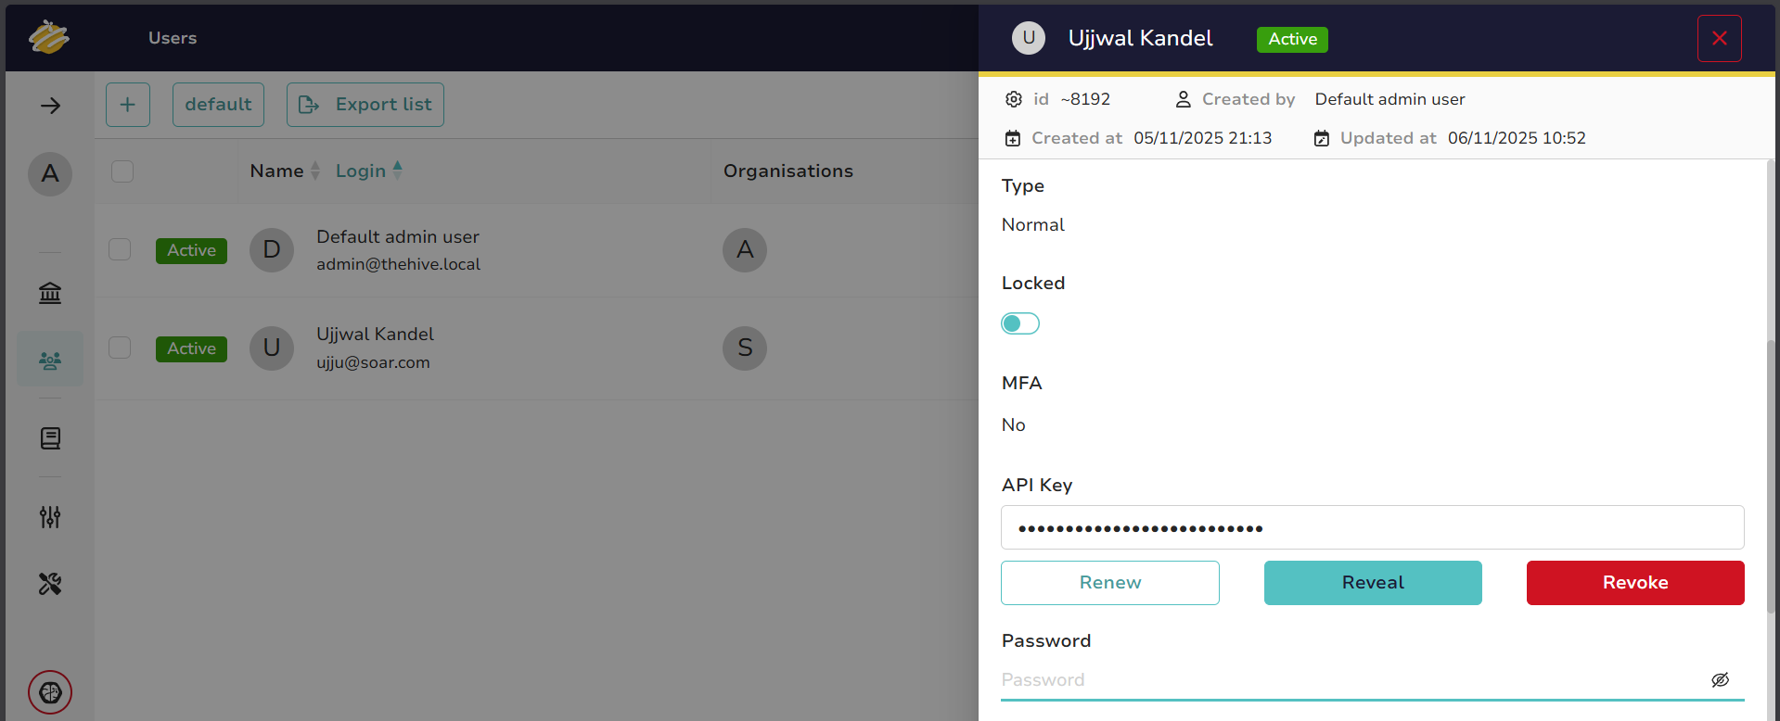
Figure 3. 82: Setting Password for The New User

3.12 Creating Analyzers
Cortex analyzers are small programs used to automate gathering information about IOC’s that we may find in our network. There are hundreds of analyzers. We’re going to focus on setting up analyzers for AbuseIPDB and VirusTotal.
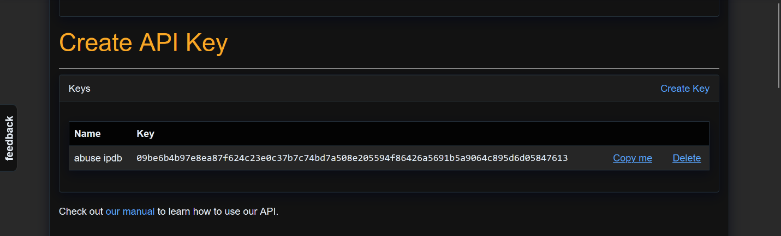
In order to set up these analyzers up we need to create accounts on VirusTotal and AbuseIPDB, once we create the accounts we will have access to a personal api key that we will be using for the analyzers.
Figure 3. 83: AbuseIPDB API Key
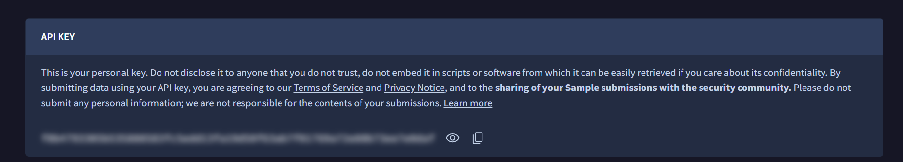
Once the accounts are created, head over to Cortex and login with the user that we created then click on the Organization section.
Figure 3. 84: VirusTotal API
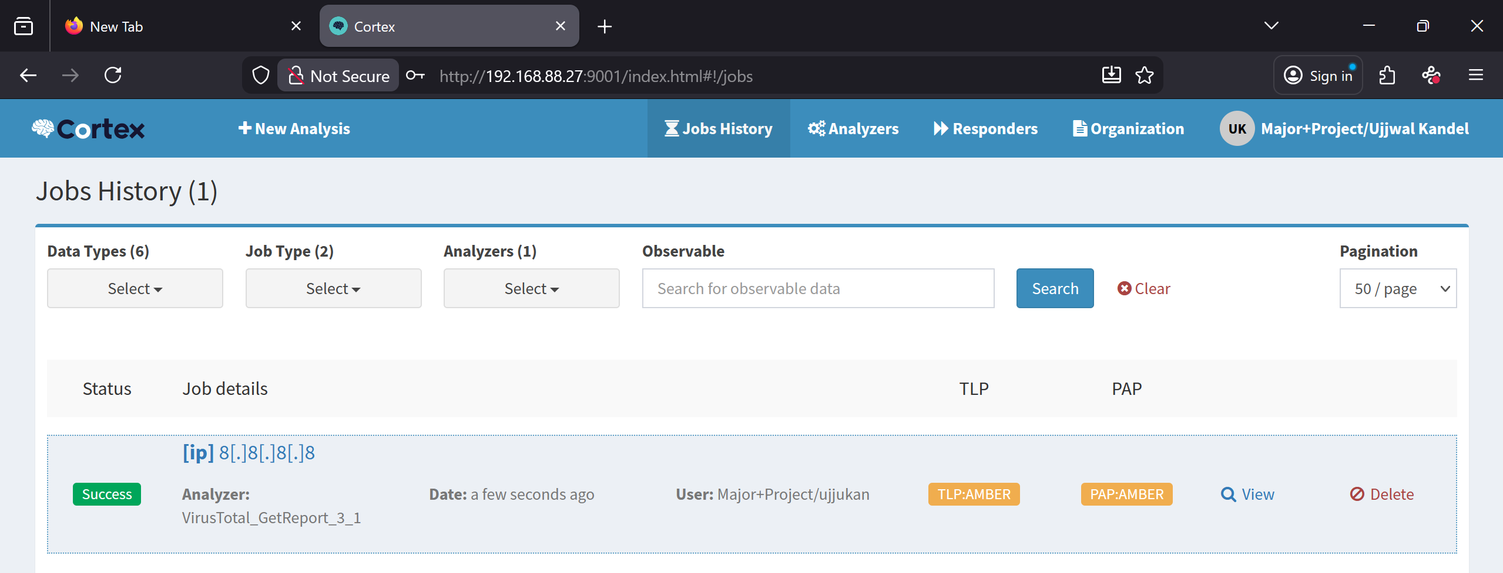
Figure 3. 85: Analyzers Navigation
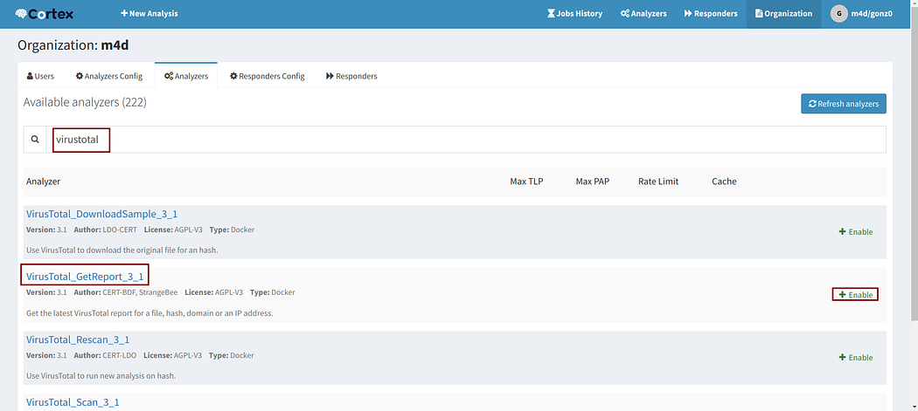
Search for virustotal and select “VirusTotal_GetReport_3_1”.
Figure 3. 86: VirusTotal
All we need to add here is our VirusTotal api key, then scroll down and save.
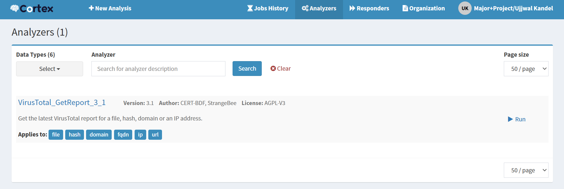
Figure 3. 87: VirusTotal Successfully Enabled
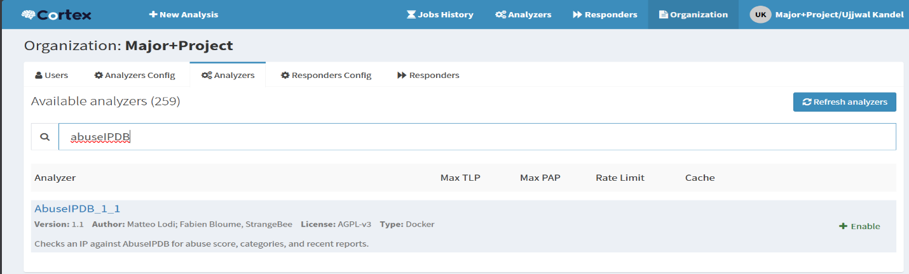
Now search for AbuseIPDB and select “AbuseIPDB_1_1”.
Figure 3. 88: AbuseIPDB
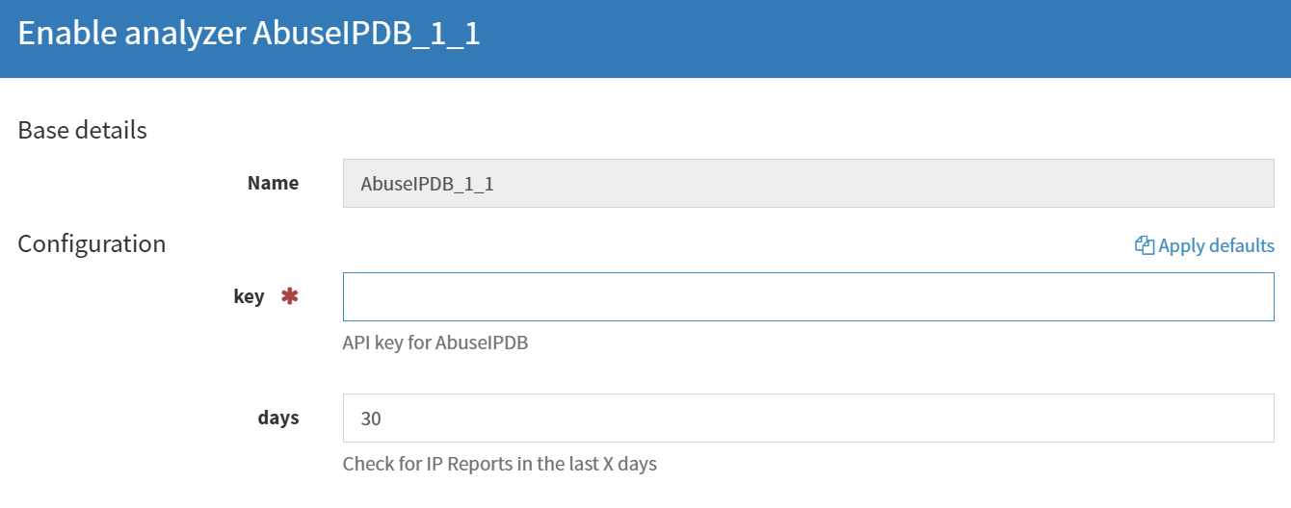
Same thing here, add your api key and save.
Figure 3. 89: Enabling AbuseIPDB Analyzer

3.13 SOAR-Based Automated Threat Intelligence System
This project develops an automated threat intelligence and incident response system using a SOAR workflow. It analyzes malicious IPs, domains, and files through multiple security platforms and sends real-time alerts to Discord, reducing manual effort and improving response speed. This workflow using a json format and script of python.
This workflow, the alert is autometically imported as a case on the hive. also automatically create overvables on this perticular case. I've already integrated cortex analyzer with hive. So I spcified here, after creating the case and overvables the analyzer will run automaticaly to analyze the observables. (To analyze I used visrustotal). I wanted to notify my team if any alert is coming to the SIEM and if any case is being crated. So I integrate Discord channel with the shuffle.
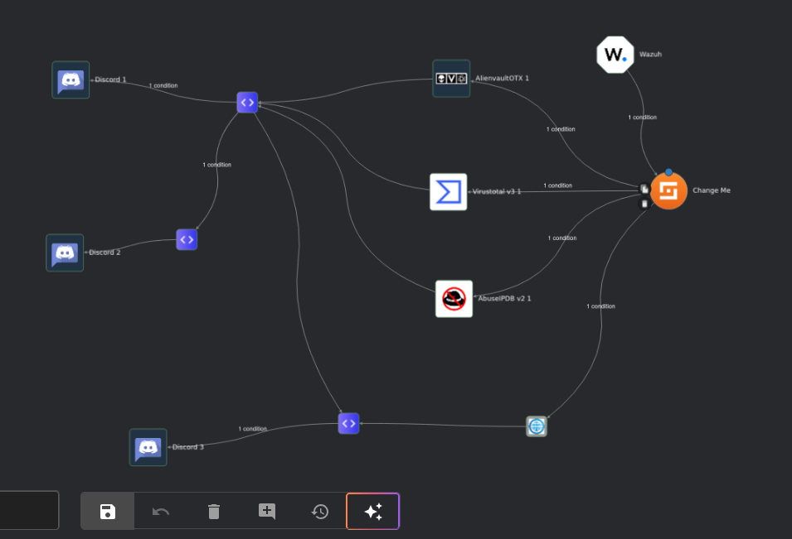
Figure 3. 90: Overall SOAR Workflow Architecture

Add Input Sources (Triggers)
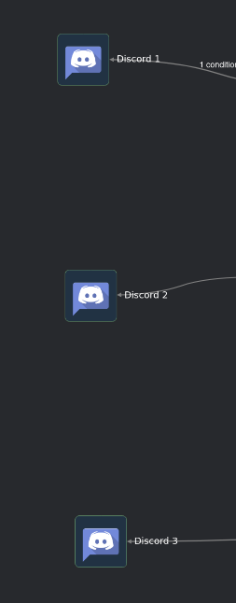
In this SOAR Workflow Architecture to Start by adding alert sources like: Add Discord 1, Add Discord 2 and Add Discord 3 These act as input triggers (they send alerts/events into the system).

Figure 3. 91 Input triggers
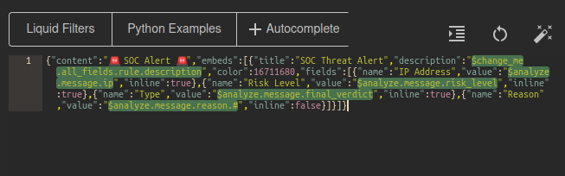
The Discord 1 input trigger uses a webhook to send alerts from a system (like a SOC/SIEM) to a Discord channel. The JSON payload defines how the alert looks, including a main message, a formatted embed, and important details like IP address, risk level, and threat type. Dynamic variables are automatically replaced with real data when an alert is triggered. The webhook URL is configured in the system, so whenever an event occurs, a structured and visually clear alert is instantly sent to Discord for monitoring.
Figure 3. 92 SOC Threat Alert from Discord
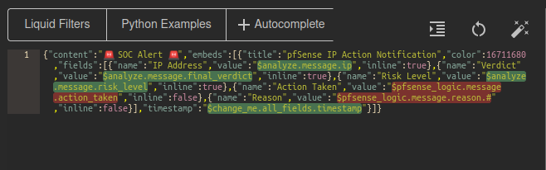
The Discord 2 input trigger sends pfSense firewall alerts to Discord using a webhook. It displays a formatted message with details like IP address, risk level, verdict, action taken, and reason. Dynamic variables automatically insert real-time data, and the timestamp shows when the event occurred. This helps track firewall actions instantly in Discord.
Figure 3. 93: Firewall Action / IP Blocking

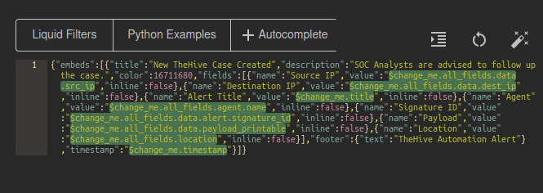
The Discord 3 input trigger sends alerts to Discord when a new case is created in TheHive. It includes details like source and destination IP, alert title, agent, signature ID, payload, and location. Dynamic variables fill in real-time data, and a timestamp shows when the case was created, helping analysts quickly track and respond to new incidents.

Figure 3. 94: New TheHive Case Alert

Connect Inputs to Processing Node:
Add an “Analyze” node, Connect:
Discord 1 → Analyze
Discord 2 →pfSense logic → Analyze
Discord 3 →Create Case →Analyze
These node processes incoming data (logs, alerts, messages).
The Analyze node collects and processes alerts from Discord 1, 2, and 3 in one place. It extracts important details like IPs, risk levels, and actions, unifying all incoming data so analysts or automated systems can quickly review and respond to security events.
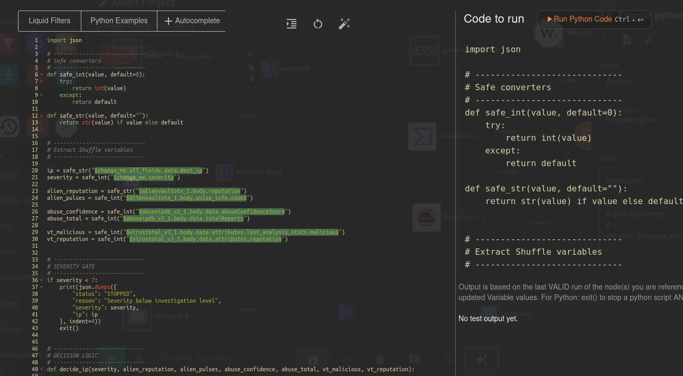

Figure 3. 95: Central processing node for all incoming alerts

This Python script takes alerts from Discord 2, checks if the IP is malicious, and automatically adds it to pfSense’s Block_List if needed. It logs whether the IP was blocked, skipped, or already exists, and outputs the results for analysis or reporting.
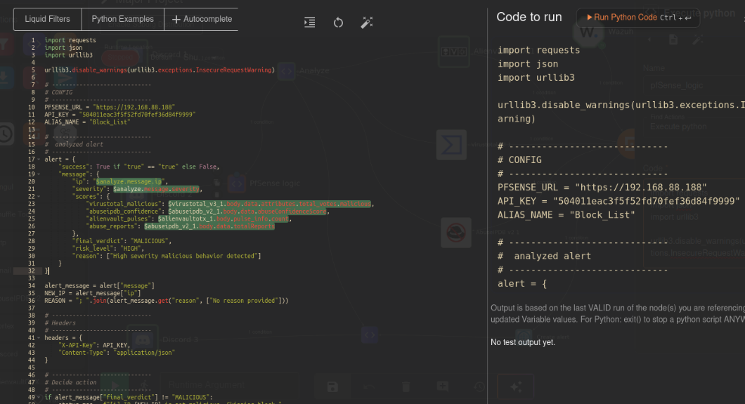

Figure 3. 96: pfSense IP Blocking Script
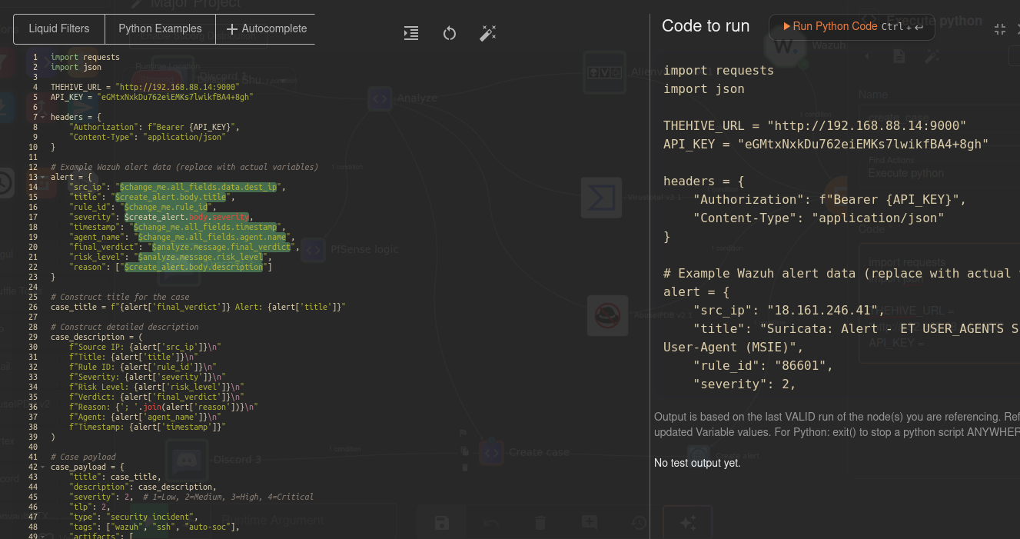
Its also python script takes alerts from Discord 3 and automatically creates a TheHive case with all relevant details like IP, alert title, severity, verdict, and reason, allowing SOC analysts to track and investigate incidents efficiently.

Figure 3. 97: TheHive Case Creation Script

3.16 Threat intelligence lookups start
The same IP is sent to multiple tools at the same time: AlienVault OTX – checks known threats, VirusTotal: checks reputation and detections, AbuseIPDB : checks abuse reports and Wazuh: correlates with security events.
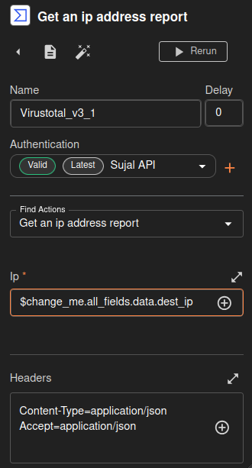
Now, Configuration of Threat Intelligence Analysis VirusTotal (malware reputation): Name= Virustotal_v3_1 and I integrate Virustototal Authentication api with the shuffle SOAR. Then, Goto find Actions: Get an ip address report. To select in ip field: $change_me.all_fields.data.dest_ip
Figure 3. 98: VirusTotal Integration

And also, Configuration of Threat Intelligence Analysis AlienVault OTX (known threat feeds). Name= AlienvaultOTX_1 and I integrate alienvaultOTX Authentication api with the shuffle SOAR. Then, goto find Actions: Get ipv4 Search. To select in ip field: $change_me.all_fields.data.dest_ip
Headers:
Content-Type=application/json
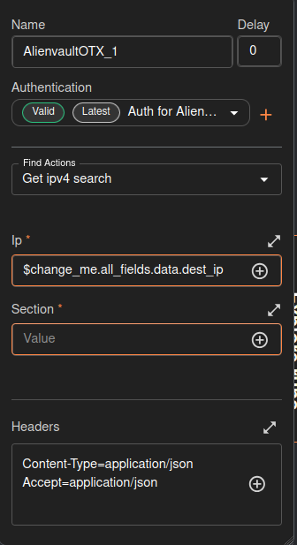
Accept=apploicaton/json
Figure 3. 99: AlienVault OTX Integration

Now, Configuration of Threat Intelligence Analysis AbuseIPDB (IP abuse history). Name= AbuseIPDB_v2_1 and I integrate AbuseIPDB Authentication api with the shuffle SOAR. Then, goto find Actions: Get check ip. To select in ip field: $change_me.all_fields.data.dest_ip
Headers: Content-Type=application/x-www-form-urlencoded
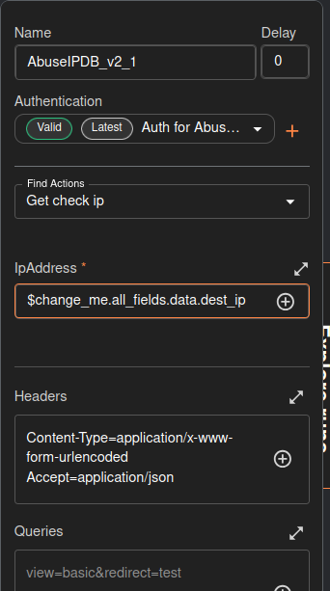
Accept=application/json
Figure 3. 100: AbuseIPDB Integration

Now, Configuration of Threat Intelligence Analysis Wazuh (log correlation). Name= Wazuh and I integrate shuffleWebhook URI with the wazuh manager.
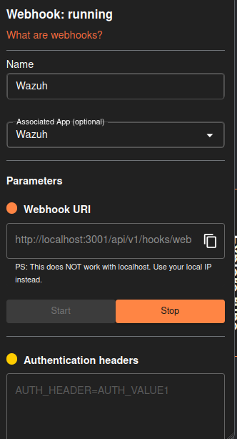
Webhook URI: http://localhost:3001/api/v1/hooks/web
Figure 3. 101: Webhook URI

After, integration and configuration has done. To click start a webhook and it runs then, each tool returns a result: for Malicious / suspicious / clean information is received.
Results are combined: All tool responses are merged into one decision flow. And, Final condition check. The system decides: Is the IP malicious? Or Is action required?

3.17 Action step (Change Me)
Configuration of Repeat back to me. Name= Change_Me. Then, goto find Actions: Repeat back to me, and select a call: $exec
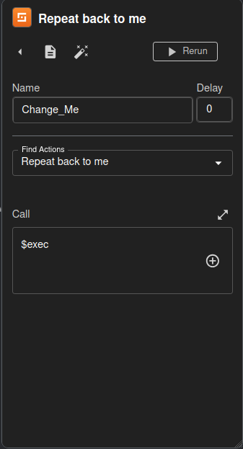
Figure 3. 102 Repeat back to me

Based on the result, an action happens:
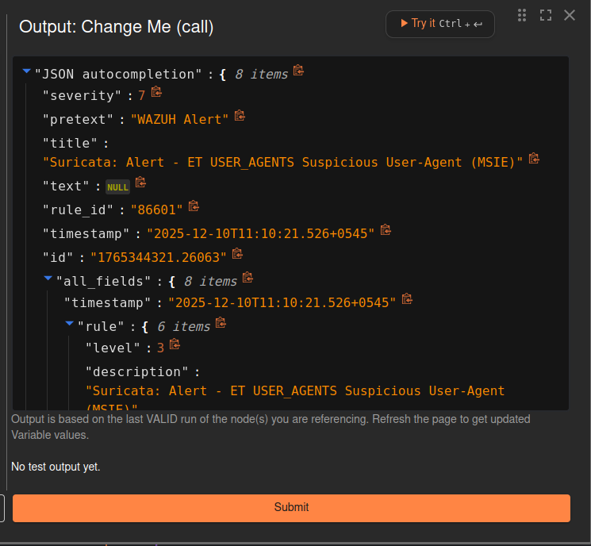
Create report, Send alert, Block IP and Notify SOC team. All analysis results are aggregated and evaluated to determine whether the indicator is malicious or safe. Then, shows a output like this in a json format. If it can detect a malicious data and to notify or sent a alert messgae with in Discord channel.

Figure 3. 103 Result Correlation and Decision Engine

Create Alert
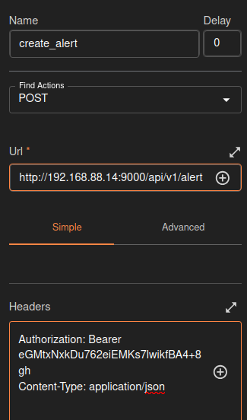
Condition → Create Alert checks if an event is a threat (like a malicious IP or file). If yes, it triggers Create Alert to notify the team via Discord, SIEM, or tickets; if no, it ignores the event.

Figure 3. 104: Decision point for generating alerts

Then, Condition checks. The system checks if the alert contains a valid IP address. And IP is extracted. Destination IP (dest_ip) is taken from the alert data.

3.19 Alert and Notification
If the indicator is malicious, an alert is sent to the Discord channel with detailed information.An alert or message is received (Discord channel name: pfsense-ip-blocks), Discord → Analyze → Tools → Condition → Alert.
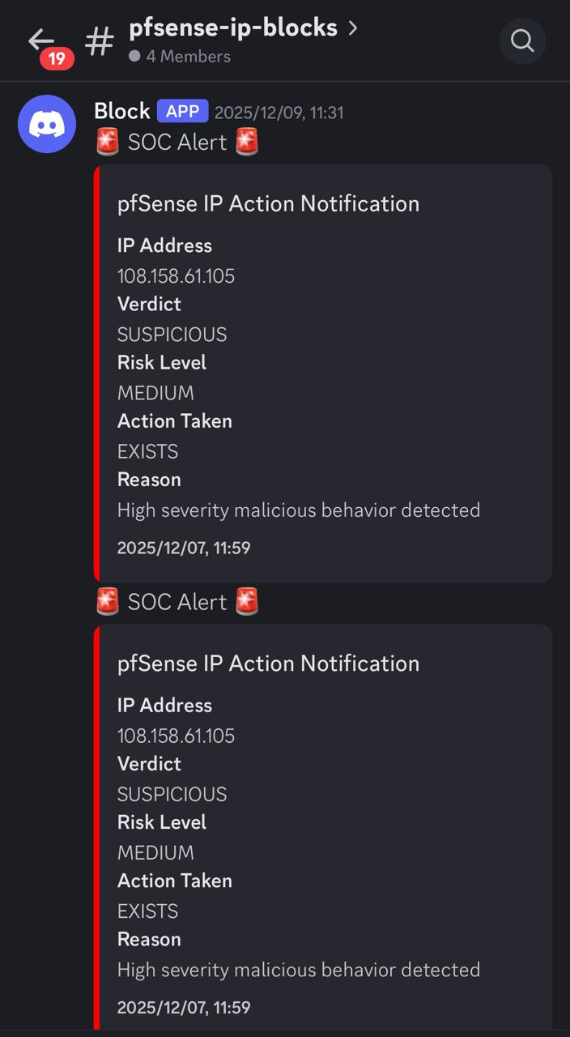
Figure 3. 105: Consolidated results and status messages

CHAPTER 4: EPILOUGE

4.1 Expected Outcomes
The expected outcome of this project is the successful deployment of a fully functional SOC environment that integrates SIEM, SOAR, Threat Intelligence, and Incident Response tools into a unified security framework. This setup will enable real-time detection of common cyber-attacks such as brute-force attempts, malware execution, and port scanning, while automated workflows will enrich alerts, generate cases, and notify analysts for faster and more accurate responses. With centralized logging and interactive dashboards, the SOC will significantly improve visibility into network activities and overall security posture. Additionally, the project will demonstrate a cost-effective SOC model suitable for educational, research, and small-business use, supported by documentation and detailed analysis of attack scenarios that highlight how the SOC identifies, investigates, and mitigates threats.

4.2 Time Schedule
Phase​ | Dates​ | Duration​ | Status​
Preliminary Research​ | Nov 30 – Dec 5​ | 6 days​ | Completed​
Infrastructure Preparation​ | Dec 6 – Dec 13​ | 8 days​ | Completed​
Tool Installation & Configuration​ | Dec 14 – Dec 21​ | 8 days​ | Completed​
System Integration​ | Dec 22 – Dec 29​ | 8 days​ | Completed​
Issue Resolution​ | Dec 30 – Jan 3​ | 5 days​ | Completed​
Testing & Verification​ | Jan 4 – Jan 20​ | 16 days​ | Completed​
Final Reporting & Documentation​ | Jan 21 – Jan 29​ | 8 days​ | Completed​
Buffer & Initial Submission Prep​ | Feb 1 – Feb 14​ | 14 days​ | Completed​
Extended Testing & Optimization​ | Feb 15 – Mar 5​ | 19 days​ | Completed​
Security Tuning & Rule Updates​ | Mar 6 – Mar 15​ | 10 days​ | Completed​
Final Review & Presentation Prep​ | Mar 16 – Mar 25​ | 10 days​ | Completed​
Final Submission Window​ | Mar 26 – Apr 1​ | 7 days​ | Final
Table 4. 1: Time Schedule
Total Weeks = ~18 Weeks

4.3 Budget Analysis
Item | Estimated Cost (USD)
Hardware (Servers / VM Hosts) | $2,000
pfSense & Network Setup | $200
SIEM & IDS Tools (Wazuh, Suricata) | $0
SOAR Platform (Shuffle) | $100
Threat Intelligence Tools (TheHive, Cortex, MISP) | $0
VirusTotal API (Optional) | $300
Storage for Logs & Backups | $400
Miscellaneous | $200
Total Estimated Budget | $3,200

Table 4. 2: Budget Analysis
1 United States Dollar = 151.67 NPR

CHAPTER 5: CONCLUSION
Open-source tools, properly integrated and automated, deliver enterprise-grade SOC capability proving that cost is no longer a barrier to effective security operations.​
All seven open-source tools were successfully integrated into a seamless detect–enrich–respond pipeline​
MTTD was reduced to 6.5 seconds on average — far below the 207-day industry average for unmonitored environments​
SOAR automation cut MTTR by over 90% compared to baseline manual investigation workflows​
The entire stack was deployed for $3,200 — less than 2% of the cost of comparable commercial platforms​
The framework is replicable and scalable — suitable for SMEs, research labs, academic institutions, and SOC training environments.

CHAPTER 6: LIMITATIONS AND ENHANCEMENTS

6.1 Limitations
High Resource Requirement – Running all the tools (pfSense, Wazuh, TheHive, Cortex, Shuffle) together uses a lot of computer memory and processing power. If your computer isn’t strong enough, the system may slow down.
Limited Scalability – The lab setup works well for a few devices, but if you try to monitor hundreds of computers or servers like a real SOC, it would need much more powerful hardware and network resources.
Complex Setup – Integrating all the tools together (SIEM, SOAR, firewall, threat intelligence) requires many steps, technical knowledge, and correct configurations. Small mistakes can break the workflow.
Human Oversight Still Needed – Even with automation, some decisions—like isolating a compromised computer—still need a person to check and approve actions. Automation can’t replace human judgment completely.

Enhancements
Add More Threat Intelligence Sources – Currently, only MISP, VirusTotal, and AlienVault OTX are used. Adding more sources would give better detection and understanding of threats.
Improve Automation – Adding more automatic responses (like quarantining infected machines or blocking suspicious IPs automatically) would reduce human workload and make response faster.
Cloud Monitoring – Modern organizations use cloud servers (AWS, Azure, Google Cloud). Extending SOC monitoring to cloud environments will make it more practical for real-world applications.
Better Dashboards and Analytics – Creating easy-to-read visual dashboards helps analysts quickly understand threats, trends, and system status, which improves efficiency.

REFERENCE
[1] J. Buechler et al., pfSense: The Definitive Guide. Reed Media Services, 2011.
[2] Open Information Security Foundation (OISF), “Suricata: Open Source IDS/IPS/NSM Engine.” [Online]. Available: https://suricata.io
[3] Wazuh Inc., “Wazuh Documentation,” 2024. [Online]. Available: https://documentation.wazuh.com
[4] Offensive Security, “Kali Linux: Penetration Testing and Ethical Hacking Linux Distribution.” [Online]. Available: https://www.kali.org
[5] Canonical Ltd. (Ubuntu) and Microsoft (Windows), official documentation. [Online]. Available: https://ubuntu.com | https://microsoft.com/windows
[6] Cortex. Cortex: Observable Analysis and Automation Engine. TheHive Project. Available at: https://github.com/TheHive-Project/Cortex
[7] TheHive. TheHive: Security Incident Response Platform (SIRP). TheHive Project. Available at: https://github.com/TheHive-Project/TheHive
[8] MISP Project. MISP – Malware Information Sharing Platform & Threat Sharing. Available at: https://www.misp-project.org
[9] Shuffle SOAR. Shuffle – Open Source Security Orchestration & Automation Platform. Available at: https://shuffler.io
[10] AlienVault OSSIM. OSSIM – Open Source Security Information and Event Management. AT&T Cybersecurity. Available at: https://cybersecurity.att.com/products/ossim
[11] VirusTotal. VirusTotal – Free Online Virus, Malware, and URL Scanner. Google. Available at: https://www.virustotal.com
[12] M. Rosso, M. Campobasso, G. Gankhuyag, and L. Allodi, "SAIBERSOC: Synthetic Attack Injection to Benchmark and Evaluate the Performance of Security Operation Centers," arXiv preprint, 2020. [Online]. Available: https://arxiv.org/abs/2010.08453
[13] N. Rastogi, S. Dutta, M. J. Zaki, A. Gittens, and C. Aggarwal, "MALOnt: An Ontology for Malware Threat Intelligence," arXiv preprint, 2020. [Online]. Available: https://arxiv.org/abs/2006.11446
[14] A. S. Shatnawi, B. Al-Duwairi, M. M. Almazari, M. S. Alshakhatreh, and A. N. Khader, "Adaptable Plug and Play Security Operations Center Leveraging a Novel Programmable Plugin-based Intrusion Detection and Prevention System," arXiv preprint, 2022. [Online]. Available: https://arxiv.org/abs/2204.04576
[15] K. Walavalkar, K. Walavalkar, Y. Jagdale, S. Gharge, and A. Nerurkar, "Security Operations Center using open-source tools," JETIR, vol. 11, no. 6, 2024. [Online]. Available: https://jetir.org/papers/JETIR2406A44.pdf

